

National Freight and Supply Chain Strategy 2025



Cover image: Sourced from Adobe Stock photos. Credit: Travel mania.

© Commonwealth of Australia 2025

ISBN 978-1-922879-47-9 (Digital)

August 2025

INFRA6331

Ownership of intellectual property rights in this publication

Unless otherwise noted, copyright (and any other intellectual property rights, if any) in this publication is owned by the Commonwealth of Australia (referred to below as the Commonwealth).

Disclaimer

The material contained in this publication is made available on the understanding that the Commonwealth is not providing professional advice, and that users exercise their own skill and care with respect to its use, and seek independent advice if necessary.

The Commonwealth makes no representations or warranties as to the contents or accuracy of the information contained in this publication. To the extent permitted by law, the Commonwealth disclaims liability to any person or organisation in respect of anything done, or omitted to be done, in reliance upon information contained in this publication.

Creative Commons licence

creative commons logo

With the exception of (a) the Coat of Arms; (b) the Department of Infrastructure, Transport, Regional Development, Communications, Sport and the Arts photos and graphics; (c) content supplied by third parties; (d) content otherwise labelled; copyright in this publication is licensed under a Creative Commons BY Attribution 4.0 International Licence.

Use of the Coat of Arms

The Department of the Prime Minister and Cabinet sets the terms under which the Coat of Arms is used. Please refer to the Commonwealth Coat of Arms - Information and Guidelines publication available at [http://www.pmc.gov.au](http://www.pmc.gov.au/).

Contact us

This publication is available in hard copy, word document, and PDF. All other rights are reserved, including in relation to any departmental logos or trademarks which may exist. For enquiries regarding the licence and any use of this publication, or if you have any additional accessibility needs in accessing this content, please contact:

**Freight Policy Team, Land Transport Policy Branch**

Department of Infrastructure, Transport, Regional Development, Communications, Sport and the Arts (DITRDCSA)

GPO Box 594, Canberra ACT 2601 Australia

Email: [freightstrategy@infrastructure.gov.au](mailto:freightstrategy@infrastructure.gov.au)

Website: [www.freightaustralia.gov.au](http://www.freightaustralia.gov.au)

# Acknowledgement of Country

We acknowledge First Nations people as the Traditional Owners and Custodians of Australia and the Torres Strait Islands. Their deep-rooted connection to the land and waterways is integral to the nation's cultural heritage and the sustainable management of resources. Aboriginal and Torres Strait Islander peoples, as part of the world's oldest living culture, have successfully managed the lands and resources across Australia for over 65,000 years. This enduring relationship with the land provides valuable insights for developing resilient and sustainable supply chains.

The ancient trade routes, which followed song lines and ceremonial paths across Aboriginal and Torres Strait Islander lands, highlight the sophisticated systems of trade and communication established by First Nations people over tens of thousands of years.

We honour the First Nations peoples of Australia and pay our respects to Elders past and present, acknowledging their contributions to the land and its stewardship, which continue to inspire sustainable practices within the national freight and supply chain framework.

Table of Contents

Acknowledgement of Country 3

Table of Contents 4

Foreword 5

From the Freight Industry Reference Panel 6

1. Overview 7

Goals 8

National Priority Action Areas 8

Strategy at a Glance 9

2. Setting the Scene 10

The growing freight task 11

Safety 15

Productivity 19

The pathway to reducing emissions for freight 22

Increasing importance of resilient supply chains 25

Skills and Workforce 31

National Urban Freight Planning Principles 33

4. Strategy Goals 34

Decarbonising the freight and supply chain sector (new goal) 35

Improved efficiency, productivity and international competitiveness (updated goal) 35

Safe, secure and resilient supply chains (updated goal) 36

A fit for purpose regulatory environment (continuing goal) 36

A skilled, portable and adaptable workforce (updated goal) 37

An informed understanding and acceptance of freight operations (continuing goal) 37

5. Action We Will Take 38

6. Key Performance Measures 40

7. How will the Strategy be delivered? 43

Working together 44

Guiding Principles 45

Keeping the Strategy relevant 46

Making progress and maintaining momentum 47

Roles and Responsibilities 48

Attachment A – Review Recommendations 50

Attachment B – National Urban Freight Planning Principles 52

# Foreword

Working together to drive future economic growth and create opportunities for the Australian freight and logistics sector

Freight transportation is the backbone of Australia’s economy, ensuring goods and products move from manufacturers and producers to retailers, businesses and consumers across the country and overseas – it is key to each and every sector. Whether transporting critical minerals in Western Australia or online shopping orders, the efficient movement of goods by our freight and logistics industry is vital to the livelihoods of all Australians.

Australia’s freight and supply chains are interconnected and cross our state and international borders, but their importance is not always recognised. Supply chains are an enabler to this country’s economic success and they ensure our trade gateways are connected to our cities and regions.

Since the National Freight and Supply Chain Strategy (the Strategy) was first released in 2019, Australia’s freight and supply chain networks have experienced significant challenges including the COVID-19 pandemic, geopolitical shifts, and increasing climate change events. These disruptions have highlighted the importance of efficient and resilient supply chains[1]. This is particularly relevant as the freight task is projected to grow 26% between 2020 and 2050 (equating to around 964 billion tonne kilometres of freight).[2]

This refreshed Strategy and new National Action Plan will set the strategic direction for governments to achieve a holistic, coordinated multi-modal approach that supports the businesses and people involved in our freight and logistics sector.

The Strategy focuses on four National Priority Action Areas: productivity, resilience, decarbonisation and data. The National Action Plan includes nationally significant actions agreed by all governments that will provide a co-ordinated approach across all freight modes when considering strategic freight priorities.

Infrastructure and Transport Ministers

# From the Freight Industry Reference Panel

Australia’s economy is underpinned by the efficient transportation of freight across vast distances and international borders. This refreshed Strategy sets the national agenda for government and industry action across all freight modes to increase the safety, productivity and resilience of freight and supply chains as the freight task continues to grow.

Our role as a Panel is to provide independent advice on the progress and delivery of the Strategy. Since 2020, we have monitored the delivery of the Strategy, which included more than 350 actions across all jurisdictions. We found this approach to implementation was not shifting the dial significantly enough in delivering the intended outcomes and goals of the Strategy.

To effect more meaningful change in the freight and logistics sector, we consider governments and industry need to take a systems-level approach to action, rather than tackling issues in isolation. The refreshed Strategy and National Action Plan take this approach, focusing on the strategic, national issues that require the coordination of all governments and industry.

In 2023, the Australian Government Minister for Infrastructure, Transport, Regional Development and Local Government, on behalf of Infrastructure and Transport Ministers, appointed three new members to the Panel to strengthen its membership and make it more representative of industry. The strengthening of the Panel’s Terms of Reference, as recommended by the Review, will also provide further opportunities for the Panel to better support the Strategy’s implementation.

The Panel advocated to bring forward the first major review of the Strategy. We have worked closely with the Department of Infrastructure, Transport, Regional Development, Communications, Sport and the Arts to provide advice regarding the Review and refresh of the Strategy and development of the new National Action Plan.

This refreshed Strategy will focus on four National Priority Action Areas, which are inter related:

* **Productivity** is a new National Priority Action Area. As Australia works towards a decarbonised and more resilient freight and supply chain network, the productivity of the sector needs to be a focus. Additionally, our supply chains must remain internationally competitive and efficient. These elements need to be considered as governments design future networks and determine the infrastructure priorities to be delivered over time.
* **Resilience** is a new National Priority Action Area and is a key priority for the freight and logistics sector. Given the critical role of freight and supply chains to everyday life, having resilient networks and supply chains, which are able to withstand disruptions and shocks, is important. There are multiple aspects to building resilience including strategic infrastructure investment, a strong and skilled freight workforce, and utilising new technologies.
* **Decarbonisation** is a new National Priority Action Area. Driving this change will be a significant challenge and will look different across transport modes and even among businesses. A concerted effort is needed for meaningful emissions reduction but efforts need to be balanced with the commercial realities of the freight and supply chain sector.
* **Data** is retained as a National Priority Action Area, in recognition of its essential role in supporting effective operations and boosting productivity. The establishment of the National Freight Data Hub has been a key achievement under the Strategy. However, further work and enhancements are needed to unlock its full potential and inform decisions made by governments and industry.

Over the past three years the Panel has identified the primary goal of improving the collection and use of consistent national freight data. The Panel has commenced work at various points with jurisdictions on developing key performance indicators for the Strategy and to improve understanding of freight performance. We strongly encourage the government to finalise this work with jurisdictions. Having clear indicators against priorities in the Strategy is the only way all governments and industry will be held accountable. Indicators will be essential to measuring the progress of the Strategy and the performance of our networks and supply chains.

Freight Industry Reference Panel

# 1. Overview

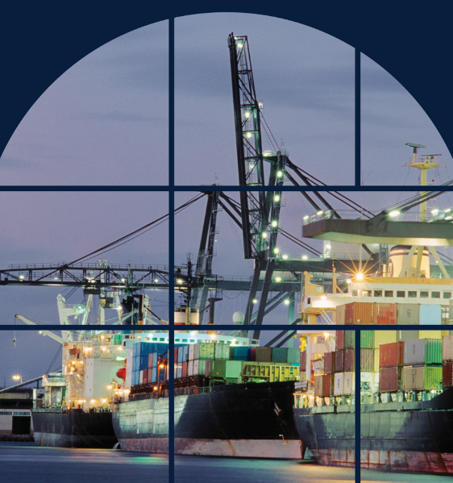

Sourced from Getty Images. Credit: John W. Banagan.

Since the Strategy was first developed in 2019, Australia’s freight task has continued to grow and this trend is forecast to continue (refer Figure 2.2).

Over the past five years, the freight and logistics sector has faced numerous challenges including the COVID-19 pandemic, extreme weather events, geopolitical shifts and worker shortages. These challenges have impacted the landscape in which the sector operates and it was timely to conduct a Review of the Strategy in 2023-24.

The Review found the foundations of the Strategy remained strong and recommended the Strategy be refreshed with a smaller number of nationally significant actions. The Review also recommended retaining the existing governance arrangements for the Strategy and developing Key Performance Indicators. Refer to **Attachment A** for the Review’s recommendations.

## Goals

This Strategy sets the agenda for a collaborative approach to deliver actions by governments and industry across all freight modes. To support more efficient supply chains, the Strategy’s goals are intended to guide governments when considering strategic freight priorities including investment decisions.

The goals of this Strategy for the next five years are:

* decarbonising the freight and supply chain sector
* improved efficiency, productivity and international competitiveness
* safe, secure and resilient supply chains
* a fit for purpose regulatory environment
* a skilled, portable and adaptable workforce
* an informed understanding and acceptance of freight operations.

## National Priority Action Areas

The Review consistently heard from stakeholders that governments had not effectively used the Strategy to drive meaningful change under the Strategy’s original Critical Action Areas. Four key areas were raised as being of higher significance for the freight and supply chain sector and have been agreed by all governments as National Priority Action Areas:

* Productivity
* Resilience
* Decarbonisation
* Data

Governments also recognise the importance of safety as a key, cross-cutting issue.

Nationally significant actions for these key areas are included in the National Action Plan.

For the purposes of this Strategy, *nationally significant* has been defined as those actions which would benefit from a multi-jurisdictional focus and/or actions which require joint government/industry collaboration to realise. Actions should also aim to achieve whole-of-network and supply chain outcomes as much as possible.

## Strategy at a Glance

### Why have a Strategy?

* Supply chains are the lifelines of this country, supporting the liveability and economic prosperity of all Australian communities.
* Ensuring safety is critical for the sector, so workers can return to their families.
* The path to decarbonisation will be challenging; action is required and needs to be balanced with commercially viable solutions.
* The freight sector needs to be resilient to disruptions, and remain internationally competitive.
* Australian governments recognise they have a role in ensuring policy and regulatory settings support the freight and supply chain sector.

**This Strategy will help guide future government freight infrastructure investment decisions.**

### Vision – The Goals for Australia’s freight and supply chain future

* decarbonising the freight and supply chain sector
* improved efficiency, productivity and international competitiveness
* safe, secure and resilient supply chains
* a fit for purpose regulatory environment
* a skilled, portable and adaptable workforce
* an informed understanding and acceptance of freight operations

### Mission – National Priority Action Areas (2025-29)

* Productivity
* Resilience
* Decarbonisation
* Data

Ensuring the safety of the freight and supply chain industry cuts across all National Priority Action Areas.

This Strategy should be read in conjunction with the companion National Action Plan 2025-29.

# 2. Setting the Scene

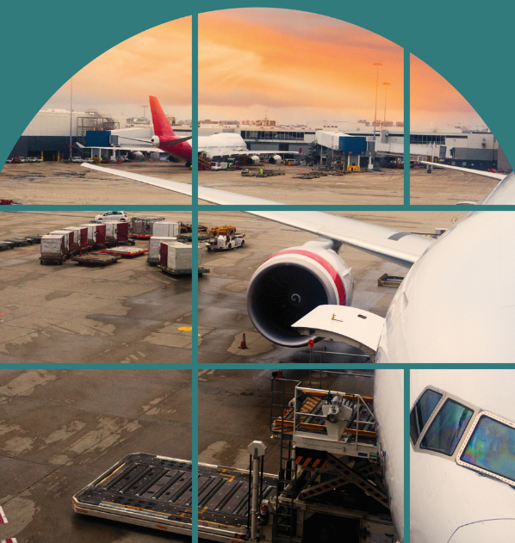

Sourced from Getty Images. Credit: stellalevi.

## The growing freight task

Each year our infrastructure operators, transport companies and logistics experts deliver about four billion tonnes of goods across Australia – that is 149 tonnes of freight for every person.[3]

Figure 2.1: Estimates of Australia’s domestic freight 2023-24 – total bulk and non-bulk freight task by mode

The graphic depicts estimates of Australia’s domestic freight task in 2023-24 by major transport mode. Each row corresponds to one transport mode and states the goods moved in billion tonne kilometres, followed by the percentage change from the previous year. 
First, road had 249 billion tonne kilometres of goods moved, which was 3.0 per cent higher than the previous year. Next, rail had 447.9 billion tonne kilometres of goods moved, which was 1.1 per cent higher than the previous year. Third, coastal shipping had 88.3 billion tonne kilometres of goods moved, which was 2.6 per cent lower than the previous year. Fourth, air freight had 0.2 billion tonne kilometres of goods moved, which was 7.6 per cent lower than the previous year. Finally, the total freight task was 785.4 billion tonne kilometres, which was 1.2 per cent higher than the previous year.

Source: BITRE, 2025, Australian Infrastructure and Transport Statistics Yearbook 2024, p77

Freight transport activity has been increasing strongly for the last 40 years with road and rail freight dominating domestic freight. During the COVID-19 pandemic, the total bulk and non-bulk freight task fell slightly, from its height of 780.0 billion tonne kilometres in 2018–19 to 759.7 billion tonne kilometres in   
2020–21. Following the pandemic, the freight task has continued its upward trend (refer figure 2.2).

The freight task is projected to grow 26% between 2020 and 2050 (to approximately 964 billion tonne kilometres) or around 0.9% per annum. The bulk rail freight task is expected to trend upwards throughout the late 2020s, largely due to the projected increase in coal and iron ore.[4] However, the freight mix is expected to change over the coming decades, with increasing investments in critical minerals projects and domestic manufacturing.

Figure 2.2: Actual and projected domestic freight task to 2050, by major transport mode

The line chart depicts the domestic freight task in billion tonne kilometres, by major transport mode. Estimates are given for the years 1971 to 2020 and projected ranges are given for the years 2021 to 2050. 
First, the road freight task trends upwards throughout both the historical and projected periods. Road historical estimates rise steadily from 24.7 billion tonne kilometres in 1971 to 222.9 billion tonne kilometres in 2020. Road is then forecast to reach 393.7 billion tonne kilometres in 2050, with a lower bound forecast of 343.3 tonne kilometres and an upper bound forecast of 449.1 billion tonnes kilometres.
Second, the rail freight task dynamics can be considered as having three distinct periods. During the first period, the rail freight task grows at an increasing rate from 23.6 billion tonne kilometres in 1971 to 405.3 billion tonne kilometres in 2015. During the second period, rail grows more slowly from 405.3 billion tonne kilometres in 2015 to a projected 484.5 billion tonne kilometres in 2024. During the third period, rail is forecast to start slowly declining before gradually flattening out, from 484.5 billion tonne kilometres in 2024 to 457.8 billion tonne kilometres in 2050. However, during this third period, the lower bound rail forecast steadily declines to 356.9 billion tonne kilometres in 2050 while the upper bound rail forecast steadily increases to 567.4 billion tonne kilometres in 2050. 
Third, the coastal shipping freight task stays relatively consistent throughout both the historical and projected periods. Coastal shipping averages 105.5 billion tonne kilometres between 1971 and 2050, and it remains within 20 per cent of this average level in 77 of those 80 years. Coastal shipping begins at 72 billion tonne kilometres in 1971, its lowest level, then ends at 110.1 tonne kilometres in 2050, and records its highest level of 123.5 billion tonne kilometres in 2007. 
Finally, the air freight task is so low in comparison to the other transport modes that its level is indistinguishable from zero for the entire period from 1971 to 2050.

Source: BITRE, Australian aggregate freight forecasts – 2022 update (Summary), p2

The projected freight growth by mode between 2020 and 2050 is summarised below:

* Total road freight is projected to grow by around 77%.
* Total rail freight is projected to grow by around 5.7%.
* Air freight activity is projected to grow by around 103%[5]. Air freight will continue to grow as demand for just-in-time delivery increases for items such as high value manufacturing and mining products, perishables such as food, urgent medical products and market flowers[6].
* Domestic coastal shipping activity is projected to remain around current levels, at approximately 120 billion tonne kilometres, out to 2050. Inter-capital container coastal freight is projected to grow by around 0.9% per annum and Bass Strait freight by around 0.5% per annum to 2050.[7]

The future freight task will also be influenced by other drivers, including population growth and increased urbanisation, Australia’s legislated emissions reduction targets and changing workforce demographics. Technological advancements including automation, digitalisation and the use of artificial intelligence in supply chain management will also play an important role in supporting more efficient supply chains into the future.

Figure 2.3: Major freight flows in Australia (by volume per mode)

The map depicts the major domestic freight flows in Australia during the 2022-23 financial year. It contains lines between the origin and destination of freight flows. The colour of the lines is determined by the transport mode (either road, rail or sea), and the thickness of the line represents the volume of freight carried along the route. The map also contains circles showing the share of the total road freight task that occurred within a capital city, as well as the share that occurred outside the capital city but within the state or territory in question. 
The largest contributors to the Australian domestic freight task shown on the map, roughly in decreasing order of freight volumes, are:
1. Bulk iron ore carried by rail in the Pilbara region in Western Australia is the largest flow on the map and constitutes 74 per cent of Australia’s total rail freight in 2023-24. The iron ore is being carried North-West towards the coast.
2. Bulk coal carried by rail constitutes another 17 per cent of total rail freight. Of this 17 per cent, 12 per cent occurred in Queensland and 5 per cent in New South Wales. Each of the bulk coal rail freight arrows points eastwards, towards the coast.
3. Road freight carried within New South Wales but outside Sydney constitutes 24 per cent of total road freight. This road freight is described as intrastate road freight.
4. Bulk bauxite carried by sea to Gladstone in Queensland constitute 43 per cent of total sea freight. Of this 43 per cent, 34 per cent comes from Weipa in Queensland and 9 per cent comes from Gove in the Northern Territory.
5. Intrastate road freight carried within Queensland, Western Australia and Victoria constitute 13 per cent, 13 per cent and 11 per cent of total road freight. 

Source: BITRE, 2024, Australian Infrastructure and Transport Statistics Yearbook 2024

Figure 2.3 shows Australia’s domestic freight task by mode, with thicker arrows indicating greater volumes of freight, but not the value or performance of Australia’s freight and supply chains. It shows that bauxite (from Weipa to Gladstone) makes up the highest volume moved by coastal shipping, while iron ore and coal make up the highest volume task moved by rail. Iron ore and coal move across privately operated rail networks in the Pilbara, Central Queensland and the Hunter Valley.

A larger image of Australia’s Freight Flows map and information on its sources is available online at the Bureau of Infrastructure and Transport Research Economics (BITRE) [2024 yearbook/Freight](https://www.bitre.gov.au/publications/2024/australian-infrastructure-and-transport-statistics-yearbook-2024/freight)

The focus of the Strategy is on our networks, such as our interstate road and rail systems, the aviation and coastal shipping networks, that carry some of our highest value freight. As they service a much wider user base, improving our networks can have significant flow on effects to the country as a whole.

To support more efficient supply chains, the Australian Government will seek to invest in infrastructure projects that contribute to the goals of the National Freight and Supply Chain Strategy. Investment decisions will be data-informed, align with the needs of the future freight network and build on the priorities outlined in the Australian Government’s Infrastructure Policy Statement. [8]

Case Study – Western Sydney International Airport

The Western Sydney International Airport (WSI) is due to open in 2026. WSI will have 24-hour capacity to connect NSW and Australia to key international markets.

The airport will include a dedicated ~35–hectare Cargo Precinct, offering landside and airside access with a purpose-built freight terminal that can process 220,000 tonnes of freight per annum initially, expanding up to 1.8 million tonnes per annum in the future.

WSI will support businesses across Sydney and regional NSW in being able to export time-sensitive, high-value goods and produce to international markets as well as importation of consumer goods and other products to meet the needs of a growing population in Western Sydney.

In partnership with the NSW Government, the Australian Government has committed significant funding to deliver new roads and upgrades to existing major roads surrounding WSI to reduce congestion and enable effective movement of freight across the Western Sydney region. This work will improve connectivity on key freight routes and access to freight and logistics businesses, such as consumer goods storage and distribution centres.

Aerial view of an aeroplane run way at dusk.


Sourced from Sourced from Western Sydney Airport Corporation.

## Safety

Safe, secure and resilient supply chains remain a priority of the Strategy

Safety is a cross-cutting issue in the Strategy and National Action Plan and should be considered in all aspects of freight and supply chain operations.

The Australian Government, through Safe Work Australia, has developed the Australian Work Health and Safety Strategy 2023-2033, with a national vision: *Safe and healthy work for all*.[9] Road transport is listed as a high priority area and is one of six industries that faces the highest rate of harm.

The National Freight and Supply Chain Strategy complements this vision and agrees that a collaborative commitment to drive continual improvements is essential to Australia’s work health and safety.

The following national safety regulators work alongside state and territory governments to support safety priorities across jurisdictions in Australia (except where specified) and have mode-specific responsibilities:

* Road – National Heavy Vehicle Regulator (NHVR) for heavy vehicles over 4.5 tonnes gross vehicle mass, except for Western Australia and the Northern Territory
* Rail – Office of the National Rail Safety Regulator (ONRSR)
* Air – Civil Aviation Safety Authority (CASA)
* Shipping – Australian Maritime Safety Authority (AMSA)

Additionally, the Australian Transport Safety Bureau investigates accidents and transport safety occurrences across Australian-registered civilian aircraft, commercial shipping (Australian flagged ships plus shipping in Australian waters or en route to Australian ports) and rail operations in Australia.[10] Australia’s decade-long national road safety agenda is outlined in the National Road Safety Strategy 2021‑30, which was agreed to by the Australian Government and all state and territory governments.

The National Road Safety Action Plan 2023-25 sets out how all governments will implement the priorities identified in the National Road Safety Strategy. The National Road Safety Action Plan was collaboratively developed by the Australian, state and territory governments, in consultation with key road safety stakeholders and the Australian Local Government Association. Specific actions are designated against nine key road safety priority areas, which include Heavy Vehicle Safety and Workplace Road Safety. Collective progress on these actions are reported in the National Road Safety Annual Progress Report. The two Strategies complement each other in the scope of safety actions governments are addressing to support Road Safety in Australia.

Upgrading existing and constructing additional heavy vehicle rest areas, in line with the forecast growth in the freight task, is an initiative intended to improve road safety for heavy vehicle drivers as well as other road uses. Funding is provided by the Australian Government under the Heavy Vehicle Rest Area initiative to projects that improve the productivity and safety outcomes of heavy vehicle operations across Australia.

There has also been a significant increase in heavy vehicle safety technologies in recent years including:

* Electronic braking systems
* Roll stability control
* Forward collision alert and avoidance
* Fatigue/distraction detection technology

These advanced safety technologies provide operators and other road users with an increased chance of detecting, avoiding or surviving a crash.[11]

Technology will continue to be a driver of change in the future freight and supply chain sector providing the potential to improve efficiency and safety for freight operators. The incorporation of Intelligent Transport Systems will provide real-time data analytics to reduce congestion, optimise freight routes and increase safety particularly for heavy vehicle operators.

Figure 2.4: Number of fatal crashes for road, aviation and maritime transport between 2010 and 2024

The line chart depicts the number of fatal crashes by transport mode between 2010 and 2024. Fatal road crashes are placed on a secondary y-axis due to its value being substantially higher.
The numbers of fatal road crashes are:
1233 in 2010. 1151 in 2011. 1190 in 2012. 1100 in 2013. 1050 in 2014. 1102 in 2015. 1200 in 2016. 1127 in 2017. 1055 in 2018. 1098 in 2019. 998 in 2020. 1048 in 2021. 1107 in 2022. 1143 in 2023. 1189 in 2024.
The numbers of fatal aviation crashes are:
19 in 2010. 25 in 2011. 27 in 2012. 33 in 2013. 20 in 2014. 27 in 2015. 15 in 2016. 22 in 2017. 17 in 2018. 22 in 2019. 17 in 2020. 14 in 2021. 22 in 2022. 19 in 2023. 20 in 2024.
The numbers of fatal marine crashes are:
2 in 2010. 6 in 2011. 6 in 2012. 6 in 2013. 3 in 2014. 2 in 2015. 2 in 2016. 5 in 2017. 2 in 2018. 2 in 2019. 6 in 2020. 6 in 2021. 2 in 2022. 2 in 2023. 3 in 2024.
A footnote states that fatal rail crashes are not included in the chart as consistent fatal rail crash statistics are not available and are measured differently to fatality statistics. The table below provides information on rail fatalities, not rail fatal crashes.


Sources: Australian Transport Safety Bureau, 2025, National Aviation Occurrence Database;   
BITRE, 2025, Australian Road Deaths Database;   
BITRE, based on AMSA Marine Incident Annual Report 2024 and earlier figures provided by AMSA.   
Note: Consistent fatal rail crash statistics are not available for inclusion in Figure 2.4 and are measured differently to fatality statistics

Figure 2.4 depicts the number of fatal crashes for road, maritime and aviation transport between 2010 and 2024. Fatal aviation crashes have remained between 14 and 23 since 2016 while marine crashes recorded between 2 and 6 from 2010. Around 18% of all road crash deaths involve a heavy vehicle.[12] Rail fatality statistics are included below, noting consistent data is only available from 2017–2024.

|  |  |  |  |  |  |  |  |
| --- | --- | --- | --- | --- | --- | --- | --- |
| 2017 | 2018 | 2019 | 2020 | 2021 | 2022 | 2023 | 2024 |
| 8 | 6 | 12 | 9 | 10 | 13 | 15 | 7 |

Source: Office of the National Rail Safety Regulator, 2025, [National Rail Safety Data](https://www.onrsr.com.au/publications/national-rail-safety-data).

Level crossings remain the highest public safety risk on the rail network (excluding suicide and trespass)[13] peaking at 15 people losing their lives due to rail-related accidents in 2023. The National Level Crossing Safety Strategy was developed by representatives from the Australian, state, territory and local governments, rail industry associations and regulators. It represents an ongoing commitment to reducing fatalities and injuries at the more than 20,000 level crossings intersecting with roads and pathways across the nation. This is particularly relevant as road freight transport vehicles are over-represented in level crossing incident data and highlights the importance of improving safety across our road and rail networks.

Figure 2.5 Heavy truck fatal crashes (per billion vehicle kilometres travelled)

The bubble chart depicts the rate of fatal road crashes involving heavy trucks per billion vehicle kilometres travelled between 2014 and 2024. The rate generally trends downwards over the period. 
The rates of heavy truck fatal road crashes per billion vehicle kilometres travelled are: 
2014-15, 9.2. 2015-26, 8.8. 2016-17, 9.1. 2017-18, 8.4. 2018-19, 8.8. 2019-20, 7.1. 2020-21, 7.5. 2021-22, 8.2. 2022-23, 7.2. 2023-24, 7.2.


Sources: BITRE, 2024, [Road deaths in crashes involving heavy vehicles – quarterly bulletin, Apr-Jun 2024](https://www.bitre.gov.au/sites/default/files/documents/heavy_bulletin_jun2024.pdf);   
BITRE, 2025, [Australian Infrastructure and Transport Statistics—Yearbook 2024](https://www.bitre.gov.au/publications/2025/australian-infrastructure-and-transport-statistics-yearbook-2024), Table 6.3.

Case Study: River Torrens to Darlington Project

The River Torrens to Darlington (T2D) Project is the largest South Australian road infrastructure project ever undertaken. Jointly funded by the South Australian and Australian governments, it will provide 10.5km of non-stop motorway through highly urbanised Adelaide suburbs and complete the 78km North-South Corridor.

Moving tens of thousands of vehicles per day into the T2D motorway and tunnels will improve road safety through the use of smart motorway technologies, coupled with active monitoring to smooth traffic flows and identify potential hazards quickly.

Additionally, safety systems will be used to coordinate an appropriate response in the event of a tunnel incident including:

* reducing lane speeds
* closing lanes
* providing warnings to motorists via overhead variable message signs
* closing a tunnel and diverting traffic to other parts of the road network

The motorway incident response team and emergency services will be notified as necessary to attend and clear any incident on the motorway as quickly as possible. This approach will ensure the safety of motorists is considered at all times.

Completing the North-South Corridor will also result in enormous productivity benefits for the freight and heavy vehicle industry. It will provide easier access to freight hubs at Adelaide Airport and Port Adelaide, and will significantly reduce fuel costs by providing a non-stop motorway.



Sourced from Department of Infrastructure and Transport, South Australia.

## Productivity

In Australia, productivity growth has been low for decades[14] and productivity in the transport, postal and warehousing sector has experienced either limited growth or a decline in most years since 2003-04.[15] This applies to both labour productivity and multifactor productivity, and may be associated with a slowdown of technological development in the sector since the widespread adoption of containerisation and B-doubles.

Government productivity levers include regulations, economic settings and setting standards; however, many aspects of freight and supply chain operations fall outside the remit of governments. There are also commercial realities involved for freight and supply chain operators which may impact their ability to invest in new technologies or to digitalise processes and facilities. While customers expect fast and reliable delivery of goods, remaining financially viable is a critical driver for businesses which operate within tight margins.

In recent years freight operations have been impacted by the increasing prevalence of extreme weather events which have severely disrupted the productivity of some key road and rail networks, particularly in regional and remote areas. For example, in 2022 the East-West rail line was closed for more than three weeks due to flooding. Such disruptions directly impact productivity as labour and equipment remain idle, and alternative transport is required at a higher cost. Long-term improvements to land transport infrastructure will be taken into consideration when rebuilding key transport networks.

The Strategy suggests that there are opportunities for productivity improvements to be realised across the freight and logistics sector, including:

* **New and emerging technologies** including robotics, automated vehicles, drones, battery electric and low emission fuelled vehicles, as well as automated warehousing and logistics facilities, present opportunities to increase productivity and support more efficient supply chain operations in Australia. While connected and automated vehicle technologies are still evolving, there are clear indications that increased automation will have positive productivity benefits for the freight and logistics sector.
* **Increased modal integration** and the establishment of connected multi-modal freight precincts across the transport network has the potential to deliver higher productivity outcomes. Intermodal terminals play a significant role in the efficient consolidation, storage and transfer of freight (including between shipping, rail, road or aviation), resulting in reduced costs and improved productivity. Projects such as the Moorebank Interstate Rail Terminal, the progression of plans to open Westport in Kwinana (WA), the Beveridge Interstate Freight Terminal and the Port Rail Shuttle Network in Melbourne, demonstrate governments’ commitment to work with the private sector to provide enabling infrastructure that delivers improved productivity benefits.
* **A fit for purpose regulatory environment** is one of the Strategy’s goals. Safety must be considered in all aspects of the regulatory environment. Working towards national consistency of regulations and standards across multiple states and territories has the potential to improve safety and reduce costs for operators. Further, modern regulatory best practice for shipping registration and coastal trading will be critical to supporting the long-term sustainability of Australia’s maritime industry and the implementation of the Strategic Fleet. The following national reform agendas all have the potential to boost wellbeing and productivity:
  + - Heavy Vehicle National Law
    - Rail Safety National Law
    - the National Rail Action Plan’s focus on interoperability
    - regulatory framework for the commercial deployment of automated vehicles
    - reviews of the *Shipping Registration Act 1981* and *Coastal Trading (Revitalising Australian Shipping) Act 2012*
    - development of the Maritime Single Window.

In recognition of the critical importance of boosting productivity in the freight sector, Productivity is a National Priority Action Area in this Strategy.

See the National Action Plan for more information.

Case Study – Moorebank Intermodal Terminal Precinct

The Moorebank Intermodal Terminal Precinct (MITP) is a significant infrastructure development, made possible through Australian Government investment, that is transforming the way containerised freight moves around the country, enhancing productivity, increasing competition and ensuring resulting cost savings are passed onto consumers.

The MITP is located in Western Sydney and is Australia’s largest intermodal logistics precinct. It is a hub for interstate and regional rail freight operations and supports the transfer of freight between services, including regional containers needing to access Port Botany. MITP is an industry-first tripartite joint venture between National Intermodal, Qube and LOGOS.

MITP is designed as an open access facility that encourages new entrants and increases competition. The Interstate Terminal at MITP is Australia’s first major metropolitan ‘independent’ interstate terminal. The commissioning of the Interstate Terminal on 4 April 2024 marked an important milestone towards building a more resilient, efficient and sustainable national supply chain, increasing productivity and sustainability outcomes. The Interstate Terminal will have capacity to handle up to 500,000 twenty-foot equivalent units (TEU) of interstate and regional freight per year.

Once the MITP is fully operational, there will be an estimated reduction of 3,000 truck journeys a day, saving 110,000 tonnes of carbon emissions annually. This is equivalent to removing over 11,000 cars from Sydney’s roads. MITP is expected to generate over $11 billion in economic benefits over 30 years, with $120 million contributing to the local economy through employment and jobs growth.

MITP further emphasises its commitment to sustainability with Australia’s largest rooftop solar installation, spanning over 850,000 square metres. This solar installation will meet the precinct’s energy needs during daylight hours.

MITP brings productivity gains by shifting container freight to rail while supporting substantial economic, resilience and environmental benefits.

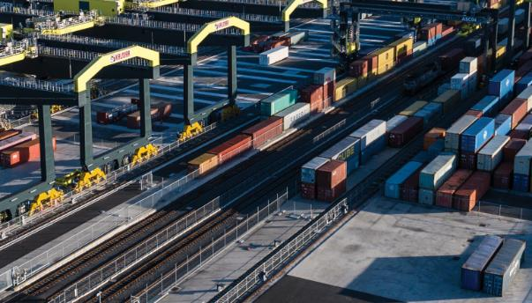

Sourced from National Intermodal. Credit: National Intermodal

## The pathway to reducing emissions for freight

**The Australian Government has legislated its commitment to reduce greenhouse gas emissions to 43% below 2005 levels by 2030 and to achieve net zero emissions by 2050.[16]**

Australia’s transport sector is the third largest source of Australia’s greenhouse gas emissions, accounting for 22% of national emissions in 2024. Road transport (heavy and light vehicles) is the main source of transport emissions (refer Figure 2.6). The projected proportion of emissions from the freight sector to 2040, as a percentage of transport emissions, is expected to increase in line with the growing freight task.[17]

The Australian Government is developing the Transport and Infrastructure Net Zero Roadmap and Action Plan (Roadmap) which will provide a strategy to reduce greenhouse gas emissions for the transport sector in line with national and international commitments. The pathway to net zero will be different for each transport mode.

Figure 2.6: Emission trends from the transport sector projected to 2040

This diagram shows emission trends from the transport sector from 1990 projected until 2040. Road transport is the main source of transport emissions at around 83%. Emissions data is measured in million tonnes of carbon dioxide equivalent. 
Emissions data from the air sector was 3 in 1990, 9 in 2024 and projected to be 11 in 2040.
Emissions data from the coastal sector was 3 in 1990, 2 in 2024 and projected to be 2 in 2040.
Emissions data from the rail sector was 2 in 1990, 4 in 2024 and projected to be 2 in 2040.
Emissions data from the road sector (light vehicles) was 43 in 1990, 59 in 2024 and projected to be 38 in 2040.
Emissions data from the road sector (heavy vehicles) was 11 in 1990, 23 in 2024 and projected to be 27 in 2040. 


Source: DCCEEW, Australia’s emissions projections 2024, Australian Government, 2024.

Road transport is the main source of transport emissions at around 83%. Heavy vehicle emissions account for 23% of all transport emissions with domestic aviation 9%, rail approximately 4% and domestic maritime approximately 2% (Figure 2.6).

Air freight is predominantly carried in the cargo holds of scheduled passenger services and by a small fleet of dedicated freight aircraft. Air freight typically comprises high-value and/or time sensitive freight. Even though aviation’s total emissions are the lowest (Figure 2.7) the sector has the highest emissions rate in grams CO2-e per tonne-kilometre.[18]

Figure 2.7: Domestic freight transport full fuel cycle greenhouse gas emissions per billion tonne kilometres of freight moved, by transport mode[19]

The line chart depicts full fuel cycle greenhouse gas emissions from domestic freight transport, by transport mode from the 1989-90 financial year to the 2023-24 financial year. Emissions are measured in gigagrams of CO2 equivalent. 
For the entire time period, road freight contributes the most emissions, followed by rail freight, then sea freight and finally air freight.
Road freight transport emissions trend steadily upwards, rising from 16925 gigagrams of CO2 equivalent in 1989-90 to 37321 gigagrams of CO2 equivalent in 2023-24.
Rail freight transport emissions also trend steadily upwards, rising from 2572 gigagrams of CO2 equivalent in 1989-90 to 4611 gigagrams of CO2 equivalent in 2023-24.
Sea freight transport emissions trend downwards from 2241 gigagrams of CO2 equivalent in 1989-90 to 1517 gigagrams of CO2 equivalent in 2011-12, then remains broadly steady until 2023-24, when it is 1449 gigagrams of CO2 equivalent.
Air freight transport emissions appear as a horizontal line close to zero, due to the values being substantially lower than for the other transport modes. The values move from 33 gigagrams of CO2 equivalent in 1989-90 to 43 gigagrams of CO2 equivalent in 2023-24. It stays between 33 and 78 gigagrams of CO2 equivalent throughout the time period.

Source: Figure 2.7 refers to full fuel cycle emission estimates for the civil domestic freight transport sector (Scope 1, 2 and 3 emissions from energy supply), in contrast to transport sector values in the Australian National Greenhouse Accounts for energy end-use (Scope 1 emissions) by domestic transport.

This Strategy has been updated to include Decarbonisation as a National Priority Action Area, in recognition of the important contribution freight, and the transportation of goods and materials will have in achieving zero emissions targets.

See the National Action Plan for more information.

There are a number of pathways available to decarbonise our freight and supply chains including:

* adopting new low and zero emission vehicles and upgrading fleets to more fuel-efficient vehicles;
* increasing the availability of well-located industrial land and increasing access to integrated intermodal facilities will result in productivity and efficiency gains;
* where possible, moving freight tasks to lower CO2 per tonne/km modes (e.g. rail) will help shift demand away from fossil fuel powered vehicles;
* adopting low carbon liquid fuels (LCLF), such as sustainable aviation fuel (SAF) and renewable diesel;
* rolling out the required energy and transport infrastructure to enable low and zero emission freight transport modes.

In planning for the transition to low and zero emission vehicles, it will also be important to address safety and other concerns of drivers and communities, especially in the early phases of using new and unfamiliar technologies.[20]

The intended benefit of the Inland Rail project is to move more freight from road to rail, especially on the Brisbane to Melbourne route. Rail can be competitive, lessen road congestion, lower road maintenance costs and operate with fewer emissions.[21] Decisions on mode of transportation will always be based on various factors including the type of goods, the market, availability of transportation and commercial considerations.

Aircraft and maritime vessels, as well as some heavy road freight vehicles and rail, will need to rely on LCLF where electrification and hydrogen are not viable. As part of the domestic manufacturing agenda, the Australian Government is providing support for a domestic LCLF industry, with an initial focus on SAF and renewable diesel to support emissions reduction in the aviation, heavy vehicle, rail and maritime sectors. Domestic production of LCLF could provide opportunities for regional development and new jobs as well as liquid fuel security benefits.[22]

## Increasing importance of resilient supply chains

Our roads, railways, airports and ports are the lifeblood of our nation’s supply chains and our economy. The importance of such fit-for-purpose freight infrastructure will only increase as Australia’s population continues to grow and the freight task expands. When these crucial freight networks are compromised by extreme weather events, or other types of national and global shocks, the repercussions are felt by industries, businesses, and our urban, regional and remote communities.[23]

Using this Strategy to inform freight infrastructure investment decisions.

This Strategy is a critical cornerstone of governments’ future freight infrastructure investment decision‑making, and is reflected in the Infrastructure Policy Statement. A national freight investment framework which considers the needs of the freight sector will help prioritise freight investment decisions and ensure all jurisdictions are aligned in their planned investments.

See the National Action Plan for more information.

A cyber security breach at one of Australia’s largest port operators in 2023 exposed the risks associated with increasing levels of supply chain digitalisation in the freight and logistics sector. Extreme weather events have also become more frequent and severe, which has led to increased pressure being placed on the national, regional, rural and remote road and rail networks. Additionally, seaports are essential to facilitating Australia’s international trade but are also highly exposed to climate change hazards including storms, flooding and sea-level rise due to their coastal locations.

The unavailability of goods when freight networks are disrupted can have major impacts, particularly on our remote and regional communities in northern and central Australia, where flooding poses the greatest and most frequent challenge.[24] Remote First Nations communities are disproportionately impacted by supply chain disruptions as a result of their seasonal isolation, inadequate storage infrastructure and a lack of alternative road and rail routes to reach these communities. Supply disruptions pose a significant risk to the food security and wellbeing of these communities.

Case Study: Northern Territory Regional Logistics Hubs

The Australian Government has committed $440 million in planned equity to create a network of Regional Logistics Hubs across the Northern Territory. The initiative will enhance different modes of transport to improve local supply chains and connection to the national transport network with a focus on upgrading capacity.

Intermodal terminals, rail sidings, warehousing and other enabling freight infrastructure will be strategically located along the Darwin-Tarcoola rail line, increasing supply chain capacity and resilience to benefit communities and boost long-term employment in remote and regional areas.

The infrastructure will support the development and operation of projects in resources, agriculture, renewable energy and construction, which is essential to the Northern Territory Government’s goal of achieving a $40 billion economy by 2030.**[25]**

Disclaimer: The Regional Logistics Hub Business Case is still under development. This map is to be used as a guide only

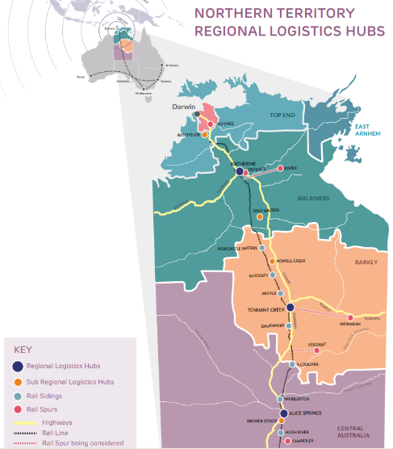

Sourced from Infrastructure NT

In 2022 it was estimated that the cost of repairing and replacing flood impacted roads was at least $3.8 billion in NSW, Queensland and Victoria.[26] Local governments are responsible for managing over 75% of Australia’s road network and are facing financial pressures caused by these types of events.[27]

In the same year, washouts and closures on the east-west rail corridor between South Australia and Western Australia reportedly cost the Australian economy $320 million to repair.[28] Some estimates further suggest that natural disasters are costing the Australian economy on average $38 billion annually – representing 2% of Australia’s Gross Domestic Product (2020 figures).[29]

An understanding of which supply chains are of national importance for different types of freight, the risks they face and how governments and industry can work together to mitigate these risks, is essential to ensure supply chains remain resilient to future potential shocks. The *2023 Road and Rail Supply Chain Resilience Review*[30]assessed 52 critical road and 13 critical rail supply chains from the National Key Freight Routes to develop a better understanding of Australia’s road and rail resilience. Key Freight Routes (KFRs) were defined in the Review report as road and rail routes connecting Australia’s nationally significant places for freight (including ports, airports and intermodal terminals) and represent the current most critical supply chain routes in Australia. Eight critical road KFRs and five critical rail KFRs were determined to have a high or very high vulnerability rating. This work has been an important reference for investment decisions which aim to build resilience along key freight routes, including the Australian Rail Track Corporation’s (ARTC) Network Investment Program.

Case Study: Australian Rail Track Corporation’s Network Investment Program

The Australian Government has committed $540 million towards the Australian Rail Track Corporation's (ARTC) Network Investment Program (NIP), which will deliver enhanced resilience and reliability to critical sections of the 8,500km Interstate Rail Freight Network. This commitment will complement an investment of $500 million from the ARTC into the program, bringing the total funding for the NIP to over $1 billion.

Investments in the network under the NIP will include the upgrade of existing crossing loops and culverts, track rehabilitation and re-railing, signalling works, and sleeper replacements. These upgrades will improve the resilience, reliability, safety, efficiency and productivity of the Interstate Rail Freight Network and strengthen Australia’s supply chains.

The investment into the NIP builds upon a number of other initiatives including $150 million invested by ARTC in resilience activities since 2022-23, and the Australian Government’s continued commitment to Inland Rail and complementary terminal infrastructure. These investments will ensure the rail freight network can effectively respond to the challenges associated with aging infrastructure, climate change and the nation’s growing freight task.

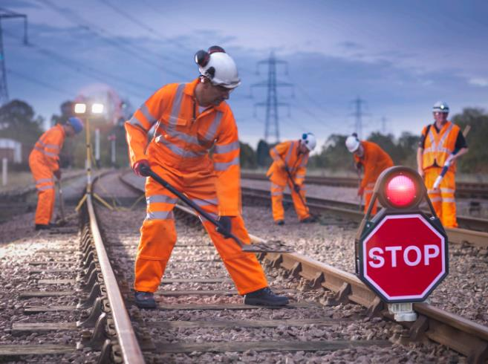

Sourced from Getty Images. Credit: Monty Rakusen.

Figure 2.8: Critical Key Freight Routes (KFRs) assessed by the Road and Rail Supply Chain Resilience Review

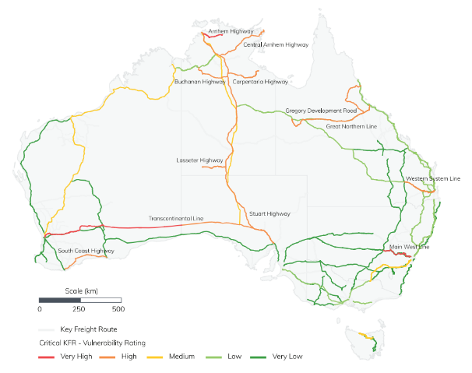

Source: Road and Rail Supply Chain Resilience Review: Critical KFRs with very high and high vulnerability ratings (p12).

The Australian Government’s *Infrastructure Policy Statement* (IPS) acknowledges the importance of freight infrastructure in each of its three strategic themes: Productivity and Resilience, Liveability, and Sustainability when assessing nationally significant land transport projects for funding.

The Productivity and Resilience theme states: The Government will seek to invest in projects that improve the resilience of critical road and rail corridors, including through upgrading existing assets that are vulnerable to risks, enhancing networks to achieve greater redundancy, as well as building to a higher standard where appropriate to create more resilient freight infrastructure after disasters.[31] The Strategy will link to and operationalise the IPS under relevant actions (see the National Action Plan for more information).

Maritime shipping accounts for 99% of the volume and around 80% of the value of Australia’s goods trade. The Australian Government has committed to establishing a maritime Strategic Fleet to build Australia’s resilience and support national security. The aim of the Strategic Fleet will be to strengthen supply chains by enabling industry to move critical cargo either around the coast or internationally in a time of crisis. A Strategic Fleet will provide maritime capabilities to address the Australian Government’s strategic needs, including to respond to disruption events, assist Defence activity and support sovereign industry. A Strategic Fleet will also provide employment and training opportunities to boost Australia’s maritime workforce capability.

Resilient freight and supply chains rely on more than just roads, ports and rail lines. The sector needs financially sustainable businesses, an appropriately skilled workforce, technological advancements and a proactive approach to decarbonisation to be resilient to the myriad of pressures facing the sector in the future. See section below on Skills and Workforce for more information.

Resilience has been embedded into one of the Strategy’s goals and included as a National Priority Action Area to reflect its importance to the future of efficient and productive freight operations. Actions in the National Action Plan have been designed specifically to respond to the Road and Rail Supply Chain Resilience Review.

See the National Action Plan for more information.

## Skills and Workforce

The availability and capability of the workforce supporting freight and supply chains is essential to ensuring the movement and availability of the goods we all need. In 2020-21 the transport sector employed   
1.25 million people across all transport activities including in-house transport services, and for-hire transport and warehousing employees.[32] This employment group includes diverse occupations and skills needs, and is dispersed across approximately 207,000 enterprises (of which 99% are small businesses) around Australia.[33]

The accumulated and flow on effects of the COVID-19 pandemic, global economic uncertainty, and disrupted supply chains have aggravated the skills shortages in the Australian labour market.[34] The freight and supply chain sector isn’t immune to these challenges, with workers in remote and regional Australia also experiencing flow on impacts including housing shortages.

Specific challenges include the increasing average age of transport operators across modes and driver shortages, along with high competition for available labour.[35] The fragmented nature of the rail network means training isn’t consistent across Australia, and an employee’s skills may not be recognised on another network.[36] There are critical shortages in a number of indirect roles in the mechanical trades including diesel motor mechanics, fitters, automotive electricians and welders.[37] Australia is facing a shortage of maritime skills including deck officers, engineers and ratings, with demand outstripping supply.[38] The aviation sector is also facing widespread workforce shortages particularly aircraft maintenance engineers, baggage handlers and pilots. The Aviation White Paper reported that approximately one-third of the aviation workforce left the sector during the COVID-19 pandemic.[39]

Automation and digitalisation in operationally-intensive areas including warehousing and distribution centres will create challenges and opportunities around the requirements for new digital skills. Similarly, the introduction of electric, low-emission and automated vehicles will also impact the range of skills required into the future for the logistics sector. For example, 40% of jobs in rail will be affected by technology, changing the way rail operates and how people will work.[40]

The Australian Government is undertaking a number of reform processes to address current and future skills challenges across the whole economy. This includes the implementation of the new National Skills Agreement, measures to increase portability of skills between networks and a digital skills roadmap through the National Rail Action Plan, measures in response to the review of the higher education system through the Universities Accord, implementation of Industry Skills Australia’s Maritime Industry Workforce Plan, and agreed recommendations from the Strategic Fleet Taskforce report. Industry Skills Australia has been established as the Job and Skills Council for the nation’s transport and logistics sector and aims to build a fit-for-purpose supply chain workforce to increase productivity, create better jobs and training facilities, and build opportunities for individuals and communities.[41] This Strategy recognises that providing more freight and logistics training opportunities in regional and remote communities can help ensure supply chains through those areas are more resilient.

The Strategy supports a safe and resilient workforce as a priority consideration, while recognising productivity gains are an important factor that contribute to a prosperous economy in Australia.

A skilled, portable and adaptable workforce is one of the Strategy’s goals.

## National Urban Freight Planning Principles

The Strategy Review recommended that the National Urban Freight Planning Principles (the Principles) be reflected in the refreshed Strategy.

The Principles were developed in 2021 by the Australian Government in collaboration with state and territory governments, in response to industry calls for improved consideration of freight in transport and land use planning.

The Principles highlight links between freight movement and land use planning, including the importance of safeguarding critical land and freight infrastructure in urban areas. They are designed to assist freight operators, urban planners, engineers, developers, transport regulators, and other practitioners to work together to balance freight needs with community amenity.

The Principles support the concept of social licence where the efficient movement of freight in and around our cities is balanced with community amenity. It is important that communities understand the vital role freight plays in our everyday lives, and the need for integrated freight operations in our communities.

The Principles are now incorporated into the Strategy to reflect the ongoing importance of land use planning when considering future freight needs, while balancing ongoing densification of residential precincts as a result of population growth.

The National Urban Policy also acknowledges the importance of the need to carefully consider freight networks in the urban planning process. Reference to the Strategy has been included in the National Urban Policy.[42] The Principles are included at **Attachment B**.

# 4. Strategy Goals

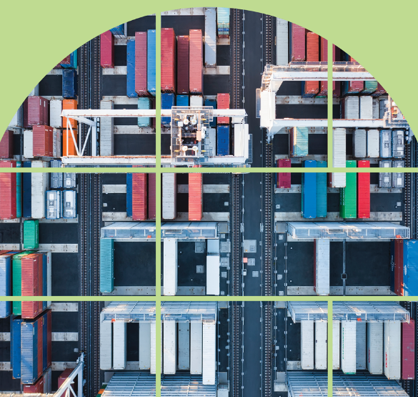

Sourced from Getty Images. Credit: Eric Yang.

**Following a review in 2023–24, the goals of this Strategy have been updated.**

Nationally coordinated and productive freight and supply chains that positively contribute to Australia’s economy.

* Decarbonising the freight and supply chain sector
* Improved efficiency, productivity and international competitiveness
* Safe, secure and resilient supply chains
* A fit for purpose regulatory environment
* A skilled, portable and adaptable workforce
* An informed understanding and acceptance of freight operations

## Decarbonising the freight and supply chain sector (new goal)

The freight and logistics sector is informed and actively involved with governments in developing the pathway to achieving net zero emissions for freight.

**Why?**

To achieve the Australian Government’s commitment to reduce emissions by 43% by 2030 and achieve net zero by 2050, a concerted effort will be required to decarbonise the freight and supply chain sector.

The transport sector is forecast to become the highest emitting sector (currently responsible for 21% of emissions) by 2030 without further action.

Transport activity is expected to continue to increase to 2050 in line with population and economic growth and a clear pathway to reduce freight emissions is necessary to guide and support the sector.

Transport infrastructure is estimated to account for 3% of Australia’s total emissions. The decarbonisation of transport infrastructure is important to achieving Australia’s net zero goals.[43]

## Improved efficiency, productivity and international competitiveness (updated goal)

Freight precincts, rail, maritime and air connections are planned, efficient and reliable. Industry is provided with greater certainty for future freight infrastructure investments. Industry utilises new technologies to improve productivity across the freight task and strengthen Australia’s international trade.

**Why?**

A coordinated approach between government and industry is necessary to lift Australia’s supply chain efficiency, productivity and international competitiveness.

Introducing advanced technologies by lowering barriers to innovation will boost productivity, increase the efficiency of supply chains, and open up new international and domestic markets.

Increased utilisation of fully integrated intermodal precincts to allow freight to move more seamlessly between transportation modes and across networks, has the capability to optimise efficiency, contingency and sustainability benefits.

Recognition of the National Urban Freight Planning Principles and the National Urban Policy, delivered over the life of the Strategy, will demonstrate the importance of protecting vital freight corridors in urban areas.

## Safe, secure and resilient supply chains (updated goal)

Australia’s freight networks and supply chains are safe, secure and resilient across all modes.

Resilience is an essential consideration when future infrastructure investment is being planned.

**Why?**

Safe, secure and resilient supply chains are essential to optimise freight efficiency across Australia.

High levels of safety across all freight modes limits disruptions and builds community trust.

Lessons from the past few years have demonstrated the importance of resilient supply chains. Improving resilience will help ensure the sector is well positioned to withstand impacts from future disruptions.

Freight infrastructure investment planning that considers long-term resilience of freight operations are priorities for governments.

## A fit for purpose regulatory environment (continuing goal)

Governments regulate Australia’s freight networks in a way that appropriately balances the benefits against the regulatory burden and costs. Safety must be considered in all aspects of the regulatory environment.

**Why?**

A whole-of-government approach to improving road freight access, coordination and regulation, particularly across jurisdictional boundaries and access regimes, will boost performance, enhance first and last mile access, reduce compliance costs and improve certainty.

A range of policy and regulatory reforms, including the removal of regulatory barriers, will be required to accelerate the uptake of low and zero emission technologies to steer Australia to net zero.

Increased interoperability across the rail sector will lead to significant safety and productivity benefits and increase the competitiveness of rail freight.

Mutual recognition of licensed occupations and skills in the transport sector will reduce inefficiencies and regulatory barriers, allowing people to work across jurisdictions (e.g. train drivers).

## A skilled, portable and adaptable workforce (updated goal)

There is a collaborative approach between governments and industry to identify workforce shortages in the freight sector to ensure appropriate training programs are available that meet future skills needs and improve workforce diversity.

**Why?**

The freight sector is having difficulty attracting workers across its various functions with certain roles also struggling to attract younger workers (e.g., a truck driver’s average age is 48 years).[44]

There can be a geographical misalignment between where appropriately skilled job seekers are located with the skills required.[45] This can have a significant impact on the labour market as many roles in the freight and logistics sector are undertaken in person.

Automation and the introduction of emerging technologies will shift the skills requirements for the sector.

With the demand for workers in the freight and logistics sector expected to increase, promoting the industry as an attractive, diverse and significant career choice will be crucial to ensure a pipeline of workers.

Industry Skills Australia is developing Workforce Plans for the transport and logistics sector to progress the Government’s Skills Reform agenda which includes introducing relevant and targeted training packages.

Encouraging mutual recognition for logistics-based credentials across jurisdictions can assist with addressing workforce shortages across the freight sector and ensure an adaptable and increasingly portable workforce nationwide.

## An informed understanding and acceptance of freight operations (continuing goal)

The freight industry works with governments and the community to deliver positive social outcomes, raise awareness and increase the acceptance from the public of the importance of freight and resilient supply chains.

**Why?**

Residential developments encroaching on freight facilities reduces both the amenity for residents and the efficient operations of those freight facilities. Investment matched to appropriate land use planning (including adherence to the National Urban Freight Planning Principles) to identify and/or protect future freight and industrial corridors is vital to the sector’s resilience.

All levels of government and industry need to work together to raise awareness of the importance of supply chains and freight.

Public acceptance of freight operations can provide reassurance to governments and/or industry to take actions to address future supply chain challenges.

# 5. Action We Will Take

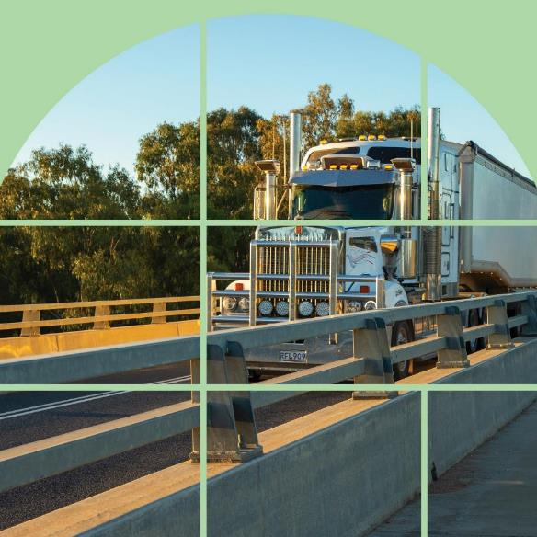

Sourced from Getty Images. Credit: Oliver Strewe.

The refreshed Strategy outlines four National Priority Action Areas that replace the original critical action areas. The National Priority Action Areas address the key gaps and areas to be strengthened over the next five years. The actions are targeted, so as not to duplicate jurisdictional freight plans and ongoing national reforms including Heavy Vehicle Road Reform, the Australian Government’s National Urban Policy, the Aviation White Paper, the establishment of a Strategic Fleet, the Transport and Infrastructure Net Zero Roadmap and Action Plan and the National Road Transport Technology Strategy and 2024-27 National Connected and Automated Vehicle (CAV) Action Plan.

The Strategy’s National Action Plan details 14 actions that will be delivered across four National Priority Action Areas. The actions are nationally significant, requiring the active collaboration of governments to deliver and/or joint government/industry collaboration. The actions also aim to achieve whole-of-network outcomes as much as possible and will provide benefits to not only the freight sector but deliver outcomes for our economy, communities and the environment.

While the Strategy and Action Plan are reviewed every five years, the National Action Plan will remain a living document over this period. As actions are completed, new ones may be introduced in their place, though the National Priority Action Areas will remain static.

The new National Action Plan can be found at [www.freightaustralia.gov.au](http://www.freightaustralia.gov.au)

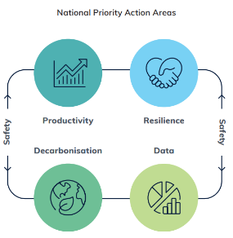

# 6. Key Performance Measures

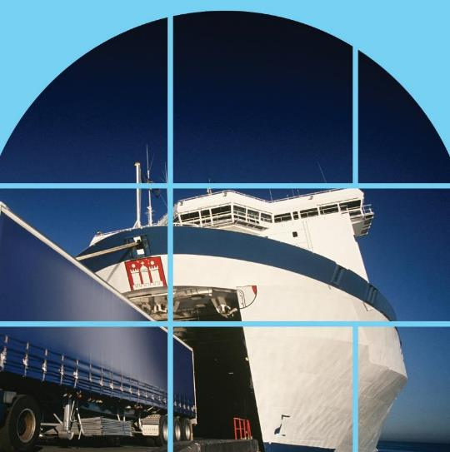

Sourced from Getty Images. Credit: moodboard.

Improved data will lead to improved decision-making for investments in the future freight network

To improve freight performance data, a KPI Working Group with Commonwealth, jurisdictional, and industry stakeholders co-designed key performance measures that align with Strategy goals. This work complements and builds upon the **National Freight Data Hub**, an earlier key action under this Strategy, which captures, improves, standardises and shares freight data across governments and industry. Improved access to data creates value for Australians by highlighting new opportunities, driving innovation and informing decision-making.

These measures are intended to provide a holistic picture of the freight and supply chain sector, and will sit alongside progress reporting on actions in the annual reporting process. Details on how they will be reported, including timing and data sources, will be provided in a detailed implementation plan.

The Strategy and Action Plan are not the only or principal factor driving trends in these measures, but have been chosen as providing a health check of the sector. This will provide performance information to benchmark and compare against, to help inform where future actions by governments may be needed.

Where possible, guiding principles for the measures are that they should have:

* a national view, with the ability to be broken out at a state/territory level and by mode​
* a consistent, documented, transparent and repeatable methodology​
* the ability to measure on an annual basis​ and as a trend over time
* a consistent approach with other work on KPIs and metrics
* the commitment to report for the life of the Strategy.

**The following five measures, linked to the first three Strategy goals, are initial measures and will be reported against annually:**

|  |  |
| --- | --- |
| Strategy Goal | Key Performance Measures |
| Decarbonising the freight and supply chain sector | * Emissions per tonne km per mode (including overall total, bulk and non-bulk). |
| Improved efficiency, productivity and international competitiveness | * Benchmark Australia’s international freight performance using the World Bank’s Logistics Performance Indicator (LPI). * Price indicators of road, rail and maritime freight provided by ABS. |
| Safe, secure and resilient supply chains | * Number of unplanned closures and  Number of days of unplanned closures on key routes. * Fatalities, injuries and near misses, including: * Number of hospitalised injuries and fatalities involving trucks. * Number of fatalities, serious injuries, and near misses involving freight trains. * Number of workplace fatalities in the Transport, Postal and Warehousing sector. * Number of serious claims in the Transport Postal and Warehousing sector. |

Future work is planned to enhance the indicators in decarbonisation and productivity, and to build new measures in the areas of regulation, workforce, and community understanding.

Case Study: CSIRO’s Transport Network Strategic Investment Tool (TraNSIT)

The Transport Network Strategic Investment Tool (TraNSIT) provides a comprehensive view of Australia’s supply chain movements for road, rail and coastal shipping. The tool uses data from 550,000 enterprises across over 200 commodities, including critical commodities such as pharmaceuticals and water treatment chemicals.

TraNSIT is used by governments to evaluate the transport benefits of infrastructure investments, and to understand the effects of disruptions on Australian communities. TraNSIT has provided valuable analysis for the Road and Rail Resilience Review, and informed investment decisions for projects, including Inland Rail. During the extreme weather season, when road and rail lines are often disrupted by floods and storms, TraNSIT provides valuable insights into the impacts on freight movements from a national to local level. By working collaboratively, sharing data and building capabilities to suit multiple needs, agencies are able to access a more comprehensive simulation model to better inform decision-making and build supply chain resilience.

The Australian Government is funding the development of new interactive and timely scenario modelling capabilities within TraNSIT to model the effects of climate change, disruptions such as floods and fires, population growth and the increasing freight task on freight flows, in order to understand supply chain volume pressures and bottlenecks. This improved data will increasingly better inform our approach to building and upgrading infrastructure for our future freight network.

Investments in TraNSIT also benefit the publicly available Supply Chain Benchmarking Dashboard - an interactive web tool that uses desensitised TraNSIT data to provide an overview of supply chains across commodities, regions, and transport modes to measure performance and identify potential strengths, weaknesses, and opportunities. To access the tool, visit: <https://benchmark.transit.csiro.au/>



Sourced from Getty Images. Credit gorodenkoff.

# 7. How will the Strategy be delivered?

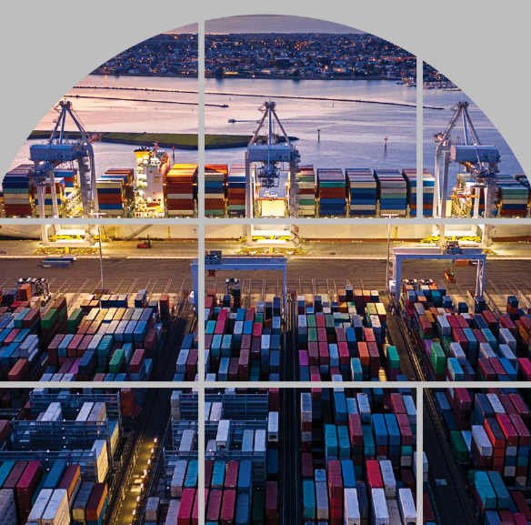

Sourced from Getty Images. Credit: Monica Bertolazzi.

## Working together

Implementing the Strategy involves a high degree of coordination and collaboration across all levels of government and active involvement of the freight industry to achieve the Strategy’s goals. The actions governments will take to implement the Strategy are detailed in the National Action Plan. The National Action Plan has been informed by priorities identified through the 2023-24 Review and in consultation with industry.

Figure 7.1: How the Strategy relates to the National Action Plan and Implementation arrangements

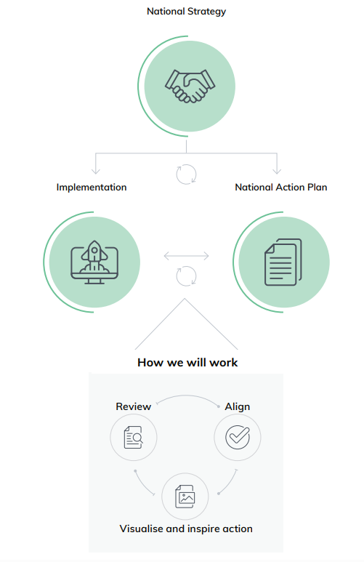

## Guiding Principles

These principles will guide actions and implementation over the life of the Strategy.

### Safety

Safety of the freight and supply chain industry will be included in all aspects of the National Priority Action Areas of the Strategy and National Action Plan.

### National Coordination

A nation-wide, collaborative and integrated approach to freight and supply chains at all levels of government and across industry.

### Evidence Based Actions

Supply chain activity and performance will be measured to monitor domestic and global competitiveness over time and identify areas where action is required to maintain and improve productivity.

### Supporting achievement of long-term vision

Robust and targeted reform and investment to ensure Australia’s freight system and supply chains are future-ready and flexible enough to meet the long-term needs of Australian business and the community.

### Responsive to emerging trends and challenges

Freight precincts have adequate capacity to handle expected future volumes, with sufficient capacity in the associated land, maritime and air connections.

### Fit-for-purpose regulation

Regulation is fit-for-purpose and outcome focused to enable innovation and the adoption of more productive, efficient, environmentally sound and safe processes.

## Keeping the Strategy relevant

The Strategy will be reviewed every five years to ensure it remains fit-for-purpose. Ongoing measurement and reporting will be critical to this process.

The first review of the Strategy was conducted in 2023-24 with the report of the review released in May 2024.

Figure 7.2: Reviewing the Strategy

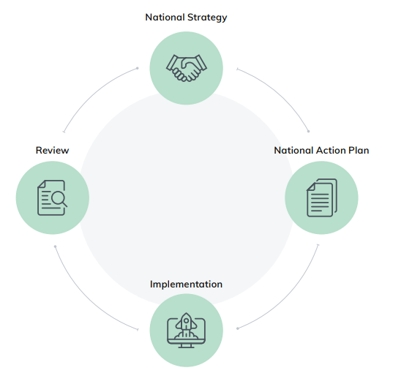

## Making progress and maintaining momentum

Governments will report to the Infrastructure and Transport Ministers Meeting through the Infrastructure and Transport Senior Officials Committee (ITSOC) at the end of each year on their progress in delivering the Strategy and National Action Plan.

The annual report will report against the implementation of actions contained in the National Action Plan and against the Key Performance Measures. The annual reporting process will also provide an opportunity to identify emerging issues and challenges that impact particular supply chains, modes or jurisdictions.

A review of the Strategy and National Action Plan will occur every five years in consultation with industry. This process will ensure continuous improvement in the Strategy’s performance and assist in identifying any gaps in the Strategy’s goals to meet Australia’s freight and supply chain challenges in an evolving landscape.

Figure 7.3: Implementing the Strategy and Action Plan

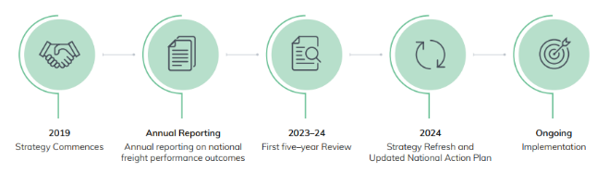

## Roles and Responsibilities

All tiers of government and industry continue to have a role to play in assisting Australia to meet its future freight needs.

The diagram below indicates the relationship between the different parties involved in delivering and reporting on the Strategy and National Action Plan. Industry and the Australian Local Government Association will be consulted throughout the Strategy’s implementation, reporting and review cycles.

### Strategy Governance

INFRASTRUCTURE AND TRANSPORT MINISTERS MEETING (ITMM)

**Membership**: Federal, state and territory minister’s responsible for transport and infrastructure.

**Role:**

* Oversee the Implementation of the Strategy
* Publish the Annual report
* Set the five–year review terms of reference
* Facilitate an integrated national approach to freight

ITMM receives advice from the Freight Industry Reference Panel and the Infrastructure and Transport Senior Officials Committee.

ITMM directs Infrastructure and Transport Senior Officials Committee and the Freight Industry Reference Panel.

INFRASTRUCTURE AND TRANSPORT SENIOR OFFICIALS COMMITTEE (ITSOC)

**Membership:** Chief Executive Officers of the departments and agencies with responsibility for transport and infrastructure issues. These officers also report to their ministers.

Role:

* Support ITMM by coordinating and progressing the strategic agenda of the committee
* Oversee the Freight Jurisdictional Working Group, annual reporting and regular review processes for the Strategy

ITSOC receives advice from the Jurisdictional Working Group and advises ITMM.

ITSOC directs the Jurisdictional Working Group.

FREIGHT JURISDICTIONAL WORKING GROUP (JWG)

**Membership:** Working level senior officials in the departments and agencies with responsibility for transport, infrastructure and planning issues. These officials also report to the Chief Executive Officer of their department and agency. Chaired by the Commonwealth.

Role:

* Managing the reporting and review process
* Where appropriate, develop a coordinated response to planning transport and other emerging freight issues
* Report to ITSOC and prepare documents for consideration by ITMM

JWG provides advice to ITSOC.

Secretariat Services for the JWG are provided by the Department of Infrastructure, Transport, Regional Development, Communications, Sport and the Arts.

FREIGHT INDUSTRY REFERENCE PANEL (FIRP)

Role:

* Support the ongoing implementation of the National Action Plan
* Give Independent Advice on the delivery of the Strategy’s goals during the annual reporting cycle
* Investigate priorities set by ITMM
* Facilitate an integrated national approach to freight

The FIRP provides advice to ITMM.

The FIRP receives direction from ITMM.

Secretariat Services for the FIRP are provided by the Department of Infrastructure, Transport, Regional Development, Communications, Sport and the Arts.

1. Review Recommendations

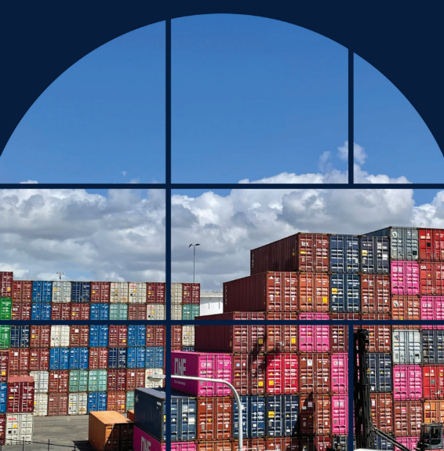

Sourced from Getty Images. Credit: Oliver Strewe.

Recommendations from the Strategy Review are listed below for reference:

Recommendation 1

The Review recommends the following amendments to the Strategy’s goals:

* a new goal on ‘decarbonising the freight and supply chain sector’
* an updated goal of ‘safe, secure and *resilient supply chains*’ and for resilience to be strengthened in the body of the refreshed Strategy
* an updated goal of ‘a skilled, *portable* and adaptable workforce’ and for skills and workforce to be strengthened in the body of the refreshed Strategy
* an updated goal of ‘improved efficiency, *productivity* and international competitiveness.’

Recommendation 2

The National Urban Freight Planning Principles be reflected in the refreshed Strategy.

Recommendation 3

The Review recommends interoperability be expanded and strengthened in the refreshed Strategy to reflect the importance of the issue and to help progress the important work already underway.

Recommendation 4

The Review recommends:

* Resilience and decarbonisation key performance indicators be implemented to measure the refreshed Strategy.
* A government/industry key performance indicators and data working group be established, with its actions to include (but not limited to):
* developing guiding principles to identify additional indicators and to support consistent data collection and the application of KPIs
* developing a data plan to more effectively capture and apply data to enhance the National Freight Data Hub and to support development of jurisdictional freight data products.

Recommendation 5

The Review recommends the following areas be agreed as National Priority Action Areas, to replace the Strategy’s current Critical Action Areas:

* decarbonisation
* productivity
* resilience
* data

### 

Recommendation 6

The Review recommends:

* The current governance arrangements be retained, with infrastructure and transport ministers to agree a refreshed strategy in 2024 and, pending that agreement, ministers to receive annual reporting under this refreshed Strategy from 2024-25.
* The Freight Industry Reference Panel’s role be strengthened to better support the Strategy’s implementation. New Terms of Reference, reflecting the Freight Industry Reference Panel’s strengthened role, should be developed for infrastructure and transport ministers’ consideration.

1. National Urban Freight Planning Principles

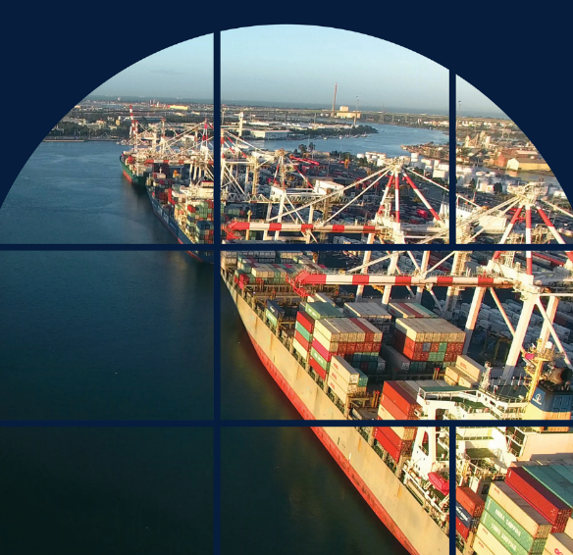

Sourced from Getty Images. Credit: David Ewing.

**National Urban Freight Planning Principles**

1. Understand the value, needs and characteristics of freight movement and incorporate in strategic and statutory transport and land use planning
2. Safeguard the resilience of all major freight handling facilities and freight corridors within and between neighbouring jurisdictions, including local government areas
3. Identify and plan areas for new freight facilities and freight-intensive land uses
4. Plan for efficient freight movements and complementary land uses around freight facilities and precincts, including intermodal terminals
5. Promote building and precinct design and usage that takes into account freight needs
6. Realise the importance of rest and refuelling facilities
7. Respond to changes in freight movements, including smaller scale freight movement and emerging technologies

The Urban Freight Planning Principles highlight linkages between freight movement and land use planning.

They will assist freight operators, planners, engineers, developers, transport regulators, and other practitioners to work together. Ensuring freight movements’ impacts on community safety and environmental outcomes are balanced with our need to ensure freight moves efficiently. This will help to maintain liveability of our cities and economic prosperity.

The Principles aim to assist state, territory and local governments (including the planning community) to make land use planning decisions that support the efficiency, effectiveness and competitiveness of the freight and supply chains in a way vital to our urban areas. This includes emphasising key concepts including understanding the value of freight, appropriately planning for and safeguarding freight facilities and movements, and responding to changes and emerging trends in business and delivery.

The application of these Principles occurs in the context of an established urban environment. They are intended to be used by all levels of government when creating, updating or reviewing planning policy documents, reviewing development applications, or developing transportation plans and are applicable to both new development and redevelopment of existing areas. The Principles are encouraged to be incorporated into state and territory level instruments and mirrored in local government planning schemes as appropriate.

Principle 1: Strategic Freight Movement Planning

Understand the value, needs and characteristics of freight movement and incorporate in strategic and statutory transport and land use planning

Why we need action

Freight is often considered as a subset of industrial activity, resulting in its unique characteristics and value being inadequately considered in planning, precinct design and development approval.

Principle 1 will ensure freight movement is adequately considered in land use planning and better balance freight needs with urban development.

What we want to achieve

* A more coordinated approach to sharing information and data between governments and industry.
  + Freight origin and destination, especially around first mile/last mile
  + What are the routes and what are the modes of transport that are most appropriate for different types of freight
  + Economic contribution of freight
* Implementation of planning decisions is supported by relevant strategic tools.
* All aspects of freight are considered during strategic planning including economic contribution, vehicle movements and characteristics of transported goods and needs of specific industries or supply chains.

Principle 2: Safeguarding Freight Resilience

Safeguard the resilience of all major freight handling facilities and freight corridors within and between neighbouring jurisdictions, including local government areas

Why we need action

There will always be competing uses in urban environments, so better, more creative design is required, including noise mitigation and planning for changing technology such as electric vehicles.

This Principle will ensure consistency and continuous operation of our freight corridors between jurisdictions, including local government areas.

What we want to achieve

* Freight infrastructure, new and existing corridors are identified and protected consistently across jurisdictions.
* Safeguarding considers ability of facilities to adapt to changing business trends.
* Impacts on residential amenity are avoided through appropriate zoning.

Principle 3: Facility Planning

Identify and plan areas for new freight facilities and freight-intensive land uses

Why we need action

Infrastructure Australia’s 2019 Infrastructure Audit highlighted that integrated land use planning has not been done well in Australian cities in the past and is likely the most significant factor in freight delays and congestion in our fast-growing cities.

Principle 3 will support proactive planning that considers potential sources of freight movement and potential population growth and developments.

What we want to achieve

* Land use planning identifies and protects land use needs for freight infrastructure, corridors and industrial activities. Corridor planning considers appropriate vehicles for freight task.
* Identification of land for freight use considers emerging business needs.
* Operation of High Productivity Vehicles are considered in developing appropriate corridors connecting freight significant areas.

Principle 4: Efficient Freight Movements

Plan for efficient freight movements and complementary land uses around freight facilities and precincts, including intermodal terminals

Why we need action

Demand for residential and mixed-use developments will likely continue encroachment on existing intermodal freight facilities and industrial activity, particularly ports. Consideration of the interaction between freight operations and other land uses must be given to impacts on ongoing functionality and intensity of operations when planning for land use changes.

Principle 4 will ensure we plan for an efficient multimodal freight network that that complements land uses around freight facilities.

What we want to achieve

* Long term freight outcomes are incorporated into strategic and statutory land use planning.
* Continuous freight activity is protected and restrictions avoided.
* Land use conflicts are avoided, protecting residential needs and amenity and enabling continuous freight activity where practical.

Principle 5: Building and Precinct Design

Promote building and precinct design and usage that take into account freight needs

Why we need action

Planning controls for new residential and commercial developments that do not consider freight delivery and waste management can lead to an over reliance on the kerbside space and create congestion and safety hazards.

Principle 5 supports building and precinct designs that facilitate adopting emerging freight technologies, such as providing electric vehicle charging and delivery innovations like parcel lockers and alternative pick-up points.

What we want to achieve

* Planning controls and building design consider freight demands and potential interaction with kerbside space and traffic flows, and safety needs of road users.
* Precinct and building design takes into account needs and facilitates benefits of emerging electric, connected and automated vehicle technology.

Principle 6: Rest Stops

Realise the importance of rest and refuelling facilities

Why we need action

We have heard that heavy vehicle drivers have difficulty finding appropriate locations to rest in urban settings, often as a result of parking restrictions in urban settings. This places significant pressure on drivers to meet fatigue regulations, and undermines their health and safety.

Principle 6 recognises the vital role they have in supporting urban freight activity.

What we want to achieve

* Land use planning incorporates consideration of fatigue regulation, safety and operational needs alongside health and wellbeing of people moving freight.
* Interaction between freight vehicles and other infrastructure users are considered in transport corridor planning, including in design of high-quality facilities to meet safety and operational requirements.

****Principle 7: Emerging Technologies

Respond to changes in freight movements, including smaller scale freight movement and emerging technologies

Why we need action

Nationally or state-led distribution of information and resources are required, recognising that local and regional planners do not have the resources to understand emerging technologies and future applications.

Principle 7 recognises that planning documents should consider infrastructure and other needs of emerging technologies in precinct and building design.

What we want to achieve

* Strategic plans take into account changes in the nature of freight and resulting effects on planning, including connected, automated and electric vehicle requirements.
* Facilities and infrastructure to support smaller scale, last-mile freight operations are considered in planning urban spaces and their contribution to liveability and business needs.
* Strategic plans incorporate long-term freight outcomes. Land use planning aligns with actions to facilitate improved delivery efficiency, including expanded access for High Productivity Vehicles.

1. Department of Infrastructure, Transport, Regional Development, Communications and the Arts, [*Infrastructure Policy Statement*](https://www.infrastructure.gov.au/sites/default/files/documents/infrastructure-policy-statement-20231114.pdf), DITRDCSA website, Australian Government, November 2023.
2. Bureau of Infrastructure and Transport Research Economics (BITRE), [*Australian aggregate freight forecasts – 2022 update (Summary)*](https://www.bitre.gov.au/sites/default/files/documents/bitre_rr154_summary_report.pdf)*,* BITRE website, Australian Government, November 2022.
3. Bureau of Infrastructure and Transport Research Economics (BITRE), [*Australian Infrastructure and Transport Statistics Yearbook 2023*](https://www.bitre.gov.au/sites/default/files/documents/bitre-yearbook-2023.pdf), BITRE website, Australian Government, December 2023.
4. Bureau of Infrastructure and Transport Research Economics (BITRE), [*Australian Infrastructure and Transport Statistics Yearbook 2023*](https://www.bitre.gov.au/sites/default/files/documents/bitre-yearbook-2023.pdf), BITRE website, Australian Government, December 2023.
5. Bureau of Infrastructure and Transport Research Economics (BITRE), [*Australian aggregate freight forecasts – 2022 update (Summary)*](https://www.bitre.gov.au/sites/default/files/documents/bitre_rr154_summary_report.pdf)*,* BITRE website, Australian Government, November 2022.
6. Department of Infrastructure and Regional Development, [*Trends- Transport and Australia’s Development to 2040 and Beyond*](https://www.infrastructure.gov.au/sites/default/files/migrated/infrastructure/publications/files/Trends_to_2040.pdf)*,* DITRDCSA website Australian Government, October 2016.
7. Bureau of Infrastructure and Transport Research Economics (BITRE), [*Australian aggregate freight forecasts – 2022 update (Summary)*](https://www.bitre.gov.au/sites/default/files/documents/bitre_rr154_summary_report.pdf)*,* BITRE website, Australian Government, November 2022.
8. Department of Infrastructure, Transport, Regional Development, Communications and the Arts, [*Infrastructure Policy Statement*](https://www.infrastructure.gov.au/sites/default/files/documents/infrastructure-policy-statement-20231114.pdf), DITRDCSA website, Australian Government, November 2023.
9. Safe Work Australia, [*Australian Work Health and Safety (WHS) Strategy 2023–2033*](https://www.safeworkaustralia.gov.au/sites/default/files/2024-06/australian_whs_strategy_2022-32_june2024.pdf), Safe Work Australia website, Australian Government, February 2023.
10. Australian Transport Safety Bureau (ATSB), [*About the ATSB*](https://www.atsb.gov.au/about_atsb/overview), ATSB Website, Australian Government, n.d.
11. National Heavy Vehicle Regulator (NHVR), [*Future Heavy Vehicle Roadmap*](https://www.nhvr.gov.au/files/media/document/276/202306-1371-future-heavy-vehicle-roadmap.pdf), NHVR website, Australian Government, June 2023.
12. Department of Infrastructure, Transport, Regional Development, Communications and the Arts, [*National Road Safety Strategy 2021-30*](https://www.roadsafety.gov.au/sites/default/files/documents/National-Road-Safety-Strategy-2021-30.pdf)*,* Road Safety website, Australian Government, December 2021.
13. National Level Crossing Safety Committee, [*National Level Crossing Safety Strategy 2023-2032*](https://www.tmr.qld.gov.au/_/media/536a03721f2a479794472a505f656e65.pdf?rev=539e0ee97bf44b4db03bfe6990c1a634&sc_lang=en&hash=7E7C48344DDB097C59AAA84B9A23D13B)*,* DITRDCSA website, Australian Government, February 2024.
14. R Bogaards,[*Australia’s productivity slowdown – Parliament of Australia*](https://www.aph.gov.au/About_Parliament/Parliamentary_departments/Parliamentary_Library/Research/Briefing_Book/47th_Parliament/AustraliasProductivitySlowdown), Parliament of Australia website, Australian Government, June 20 2022.
15. Australian Bureau of Statistics (ABS), [*Estimates of Industry Multifactor Productivity, 2022-23 financial year*](https://www.abs.gov.au/statistics/industry/industry-overview/estimates-industry-multifactor-productivity/2022-23), ABS website, Australian Government, December 2023.
16. Parliament of Australia (APH), [*Climate Change Bill 2022*](https://www.aph.gov.au/Parliamentary_Business/Bills_Legislation/Bills_Search_Results/Result?bId=r6885#:~:text=Introduced%20with%20the%20Climate%20Change,statement%3B%20requires%20the%20Climate%20Change) , APH website, Australian Government, September 2022.
17. Department of Climate Change, Energy, the Environment and Water (DCCEEW), [*Australia’s emissions projections 2024*](https://www.dcceew.gov.au/climate-change/publications/australias-emissions-projections-2024), DCCEEW, Australian Government, 2024.
18. Bureau of Infrastructure and Transport Research Economics (BITRE), [*Australian Infrastructure and Transport Statistics Yearbook 2023*](https://www.bitre.gov.au/sites/default/files/documents/bitre-yearbook-2023.pdf), BITRE website, Australian Government, December 2023.
19. Bureau of Infrastructure and Transport Research Economics (BITRE), [*Australian Infrastructure and Transport Statistics Yearbook 2023*](https://www.bitre.gov.au/sites/default/files/documents/bitre-yearbook-2023.pdf), BITRE website, Australian Government, December 2023.
20. Climateworks Centre,[*Developing Freight Decarbonisation Summary Report*](https://www.climateworkscentre.org/wp-content/uploads/2023/10/Delivering-freight-decarbonisation-Summary-Report-Climateworks-Centre-October-2023.pdf), Climateworks Centre website, October 2023.
21. K Schott, [*The Delivery of Inland Rail: An Independent Review*](https://www.infrastructure.gov.au/sites/default/files/documents/independent-review-of-inland-rail-report.pdf), DITRDCSA website, Australian Government, January 2023.
22. Department of Infrastructure, Transport, Regional Development, Communications and the Arts, [*Transport and Infrastructure Net Zero Consultation Roadmap*](https://www.infrastructure.gov.au/sites/default/files/documents/transport-and-infrastructure-net-zero-consultation-roadmap.pdf), DITRDCSA website, Australian Government, May 2024.
23. House of Representatives, [*Inquiry into the implications of severe weather events on the national regional, rural, and remote road network*](https://parlinfo.aph.gov.au/parlInfo/download/committees/reportrep/RB000033/toc_pdf/Inquiryintotheimplicationsofsevereweathereventsonthenationalregional,rural,andremoteroadnetwork.pdf), Parliament of Australia website, Australian Government, December 2023.
24. Bureau of Infrastructure and Transport Research Economics (BITRE), [*Road and Rail Supply Chain Resilience Review*](https://www.bitre.gov.au/sites/default/files/documents/Road%20and%20Rail%20Supply%20Chain%20Resilience%20Review_Final.pdf)*,* BITRE website, Australian Government, February 2023.
25. Infrastructure NT,[*Regional Logistics Hubs*](https://infrastructure.nt.gov.au/project/regional-logistics-hub)*,* Infrastructure NT website, NT Government, April 2024.
26. Australian Road Research Board (ARRB), [*Building better roads to prevent another $3.8 billion blowout*](https://www.arrb.com.au/news/building-better-roads-to-prevent-another-3.8-billion-blowout), ARRB website, December 2022.
27. House of Representatives, [*Inquiry into the implications of severe weather events on the national regional, rural, and remote road network*](https://parlinfo.aph.gov.au/parlInfo/download/committees/reportrep/RB000033/toc_pdf/Inquiryintotheimplicationsofsevereweathereventsonthenationalregional,rural,andremoteroadnetwork.pdf), Parliament of Australia website, Australian Government, December 2023.
28. N Wallace, [*Federal Budget 2024-2025: More than $1 billion for resilient and reliable rail infrastructure*](https://ara.net.au/media-release/federal-budget-2024-2025-more-than-1-billion-for-resilient-and-reliable-rail-infrastructure/)*,*Australian Railway Association, May 2024.
29. Australian Business Roundtable for Disaster Resilience & Safer Communities, [*Special report: Update to the economic costs of natural disasters in Australia*](https://australianbusinessroundtable.com.au/assets/documents/Special%20report:%20Update%20to%20the%20economic%20costs%20of%20natural%20disasters%20in%20Australia/Special%20report%20_Update%20to%20the%20economic%20costs%20of%20natural%20disasters%20in%20Australia.pdf), Australian Business Roundtable for Disaster Resilience & Safer Communities webpage, 2021.
30. Bureau of Infrastructure and Transport Research Economics (BITRE), [*Road and Rail Supply Chain Resilience Review*](https://www.bitre.gov.au/sites/default/files/documents/Road%20and%20Rail%20Supply%20Chain%20Resilience%20Review_Final.pdf)*,* BITRE website, Australian Government, February 2023.
31. Department of Infrastructure, Transport, Regional Development, Communications and the Arts, [*Infrastructure Policy Statement*](https://www.infrastructure.gov.au/sites/default/files/documents/infrastructure-policy-statement-20231114.pdf), DITRDCSA website, Australian Government, November 2023.
32. Bureau of Infrastructure and Transport Research Economics (BITRE),[*Economic Contribution of Transport in Australia, 2020-21*](https://www.bitre.gov.au/sites/default/files/documents/BITRE-Statistical-Release-ABS-ATEA-2020-21.pdf)*,* BITRE website, Australian Government, 2023.
33. Industry Skills Australia (ISA), [*Transport and Logistics*](https://www.industryskillsaustralia.org.au/our-industries/transport-logistics)*,* ISA website, n.d.
34. Jobs and Skills Australia (JSA), [*Skills Shortage Drivers- A Companion Paper*](https://view.officeapps.live.com/op/view.aspx?src=https%3A%2F%2Fwww.jobsandskills.gov.au%2Fsites%2Fdefault%2Ffiles%2F2024-03%2Fskills_shortage_drivers_-_a_companion_paper.docx&wdOrigin=BROWSELINK), JSA website, Australian Government, April 2024.
35. Industry Skills Australia (ISA),[*Transport and Logistics Industry 2024 Workforce Plan*](https://isa-files.azureedge.net/2024-07/Transport%20and%20Logistics%20Industry%202024%20Workforce%20Plan.pdf)*,* ISA Website, Australian Government, 2024.
36. Industry Skills Australia (ISA),[*Rail Industry 2024 Workforce Plan*](https://isa-files.azureedge.net/2024-07/Rail%20Industry%202024%20Workforce%20Plan.pdf)*,* ISA Website, Australian Government, 2024.
37. Industry Skills Australia (ISA),[*Transport and Logistics Industry 2024 Workforce Plan*](https://isa-files.azureedge.net/2024-07/Transport%20and%20Logistics%20Industry%202024%20Workforce%20Plan.pdf)*,* ISA Website, Australian Government, 2024.
38. Department of Infrastructure, Transport, Regional Development, Communications and the Arts, [*Strategic Fleet Taskforce Final Report*,](https://www.infrastructure.gov.au/sites/default/files/documents/strategic-fleet-taskforce-final-report.pdf) DITRDCSA website, Australian Government, November 2023.
39. Department of Infrastructure, Transport, Regional Development, Communications and the Arts, [*Aviation White Paper*](https://www.infrastructure.gov.au/sites/default/files/documents/awp-aviation-white-paper.pdff), DITRDCSA website, Australian Government, August 2024.
40. National Transport Commission, [*Meeting future rail skills demand*](https://www.ntc.gov.au/project/meeting-future-rail-skills-demand), National Transport Commission, 2024.
41. Industry Skills Australia (ISA), [*Who we are*](https://www.industryskillsaustralia.org.au/who-we-are)*,* ISA website, n.d.
42. Department of Infrastructure, Transport, Regional Development, Communications, Sport and the Arts, [*National Urban Policy*](https://www.infrastructure.gov.au/sites/default/files/documents/national-urban-policy.pdf), DITRDCSA website, Australian Government, 2024.
43. Department of Infrastructure, Transport, Regional Development, Communications and the Arts, [*Transport and Infrastructure Net Zero Consultation Roadmap*](https://www.infrastructure.gov.au/sites/default/files/documents/transport-and-infrastructure-net-zero-consultation-roadmap.pdf), DITRDCSA website, Australian Government, May 2024.
44. Jobs and Skills Australia (JSA), [*Truck Drivers (General) Labour Market Insights*](https://www.jobsandskills.gov.au/data/occupation-and-industry-profiles/occupations/733111-truck-drivers-general), JSA website, Australian Government, n.d.
45. The Treasury, [*Treasury Round Up March 2024*](https://treasury.gov.au/sites/default/files/2024-03/p2024-495252-full-report_0.pdf), Treasury website, Australian Government, March 2024.