

National Freight and Supply Chain Strategy

National Action Plan 2025-29

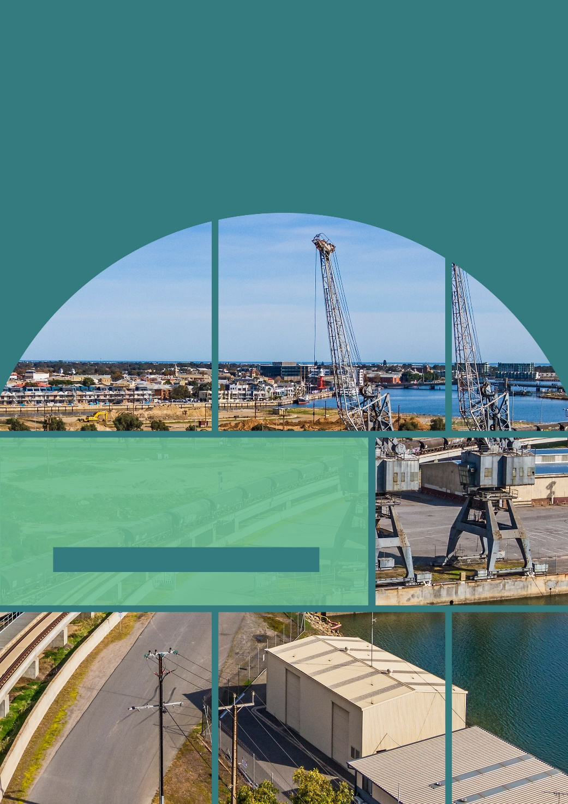

Cover image: Sourced from Getty Images. Credit: BeyondImages.

© Commonwealth of Australia 2025

ISBN 978–1–922879–49–3 (Digital)

August 2025

INFRA6331

Ownership of intellectual property rights in this publication

Unless otherwise noted, copyright (and any other intellectual property rights, if any) in this publication is owned by the Commonwealth of Australia (referred to below as the Commonwealth).

Disclaimer

The material contained in this publication is made available on the understanding that the Commonwealth is not providing professional advice, and that users exercise their own skill and care with respect to its use, and seek independent advice if necessary.

The Commonwealth makes no representations or warranties as to the contents or accuracy of the information contained in this publication. To the extent permitted by law, the Commonwealth disclaims liability to any person or organisation in respect of anything done, or omitted to be done, in reliance upon information contained in this publication.

Creative Commons licence



With the exception of (a) the Coat of Arms; (b) the Department of Infrastructure, Transport, Regional Development, Communications, Sport and the Arts photos and graphics; (c) content supplied by third parties; (d) content otherwise labelled; copyright in this publication is licensed under a Creative Commons BY Attribution 4.0 International Licence.

Use of the Coat of Arms

The Department of the Prime Minister and Cabinet sets the terms under which the Coat of Arms is used. Please refer to the Commonwealth Coat of Arms - Information and Guidelines publication available at [http://www.pmc.gov.au](http://www.pmc.gov.au/).

Contact us

This publication is available in hard copy, word document, and PDF. All other rights are reserved, including in relation to any departmental logos or trademarks which may exist. For enquiries regarding the licence and any use of this publication, please contact:

**Freight Policy Team, Land Transport Policy Branch**

Department of Infrastructure, Transport, Regional Development, Communications, Sport and the Arts

GPO Box 594, Canberra ACT 2601 Australia

Email: [freightstrategy@infrastructure.gov.au](mailto:freightstrategy@infrastructure.gov.au)

Website: [www.freightaustralia.gov.au](http://www.freightaustralia.gov.au)

Table of Contents

Table of Contents 3

Acknowledgement of Country 4

Introduction 5

Summary of Actions 7

1. Productivity 11

2. Resilience 13

3. Decarbonisation 15

4. Data 17

# Acknowledgement of Country

“Aboriginal and Torres Strait Islander peoples, as part of the world’s oldest living culture, have successfully managed the lands and resources across Australia for over 65,000 years.”

We acknowledge First Nations people as the Traditional Owners and Custodians of Australia and the Torres Strait Islands. Their deep-rooted connection to the land and waterways is integral to the nation’s cultural heritage and the sustainable management of resources. Aboriginal and Torres Strait Islander peoples, as part of the world’s oldest living culture, have successfully managed the lands and resources across Australia for over 65,000 years. This enduring relationship with the land provides valuable insights for developing resilient and sustainable supply chains. The ancient trade routes, which followed song lines and ceremonial paths across Aboriginal and Torres Strait Islander lands, highlight the sophisticated systems of trade and communication established by First Nations people over tens of thousands of years. We honour the First Nations peoples of Australia and pay our respects to Elders past and present, acknowledging their contributions to the land and its stewardship, which continue to inspire sustainable practices within the national freight and supply chain framework.

# Introduction

The National Freight and Supply Chain Strategy (Strategy) sets the agenda for a collaborative approach to deliver government action across all freight modes. The Strategy aims to ensure freight and supply chains continue to provide reliable access to vital goods and materials from across the globe, as well as support valuable export supply chains that are vital to Australia’s economy.

This National Action Plan (Action Plan) sits alongside the Strategy and details key actions to be delivered by governments to achieve the goals of the Strategy. The Action Plan is informed by the priorities of all governments and the freight and supply chain sector and will focus on four National Priority Action Areas. In addition, safety is recognised as a cross-cutting issue. The safety of workers is at the forefront in all freight operations.

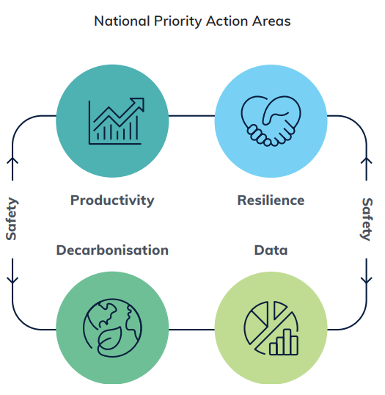

The actions contained in this Action Plan will help ensure future investment decision making is informed by a strong evidence base. The Action Plan sets out 14 actions that will be delivered across these priority areas, many also incorporating safety elements. These actions are nationally significant, requiring the active collaboration of governments and industry to deliver. These actions aim to achieve whole of network and supply chain outcomes. In implementing these actions, governments will consider how to incorporate First Nations perspectives. A comprehensive implementation plan will be developed and published, outlining how these actions will be delivered.

While the Strategy and Action Plan are reviewed every five years, the Action Plan will remain a living document over this period. As actions are completed, new ones may be introduced, though the four National Priority Action Areas, together with safety, will remain in place, and be reconsidered at the five-year review.

# Summary of Actions

Ensuring the safety of the freight and supply chain industry cuts across all National Priority Action Areas.

## Productivity

|  |  |  |  |
| --- | --- | --- | --- |
| Action | Lead | Key Collaborators | Timeframe |
| Action 1.1:  Define and model the current freight and supply chain network | Commonwealth | NSW, SA, WA, Vic, Qld | 2025-26 |
| Action 1.2:  Model the ideal future freight network in 2040 | Commonwealth | NSW, SA, WA, Vic, Qld | 2026-27 |
| Action 1.3:  Improve freight education and awareness in urban and industrial land use planning | Commonwealth | NSW, WA, Australian Local Government Association, Vic | 2025-26 |
| Action 1.4:  Promote uptake of technology to improve safety and productivity | All | All jurisdictions through the Jurisdictional Working Group | Ongoing |

## Resilience

|  |  |  |  |
| --- | --- | --- | --- |
| Action | Lead | Key Collaborators | Timeframe |
| Action 2.1:  Develop a National Freight Resilience Plan | Commonwealth | All jurisdictions through the Jurisdictional Working Group | 2025 |
| Action 2.2:  Conduct periodic supply chain risk and resilience modelling | Commonwealth | WA, Qld, NSW | 2027-28 |
| Action 2.3:  Develop a Freight Infrastructure Investment Framework | Commonwealth | Vic, NSW, Qld, Tas, WA | 2025 |
| Action 2.4:  Conduct a current and future skills gap analysis for the freight and logistics sector | Commonwealth | Vic | 2026 |

## Decarbonisation

|  |  |  |  |
| --- | --- | --- | --- |
| Action | Lead | Key Collaborators | Timeframe |
| Action 3.1:  Develop government and industry frameworks to collaborate on the transition to net zero | Victoria | All jurisdictions through the Jurisdictional Working Group | 2025-26 |
| Action 3.2:  Support development of a domestic low carbon liquid fuels industry | Commonwealth | Nil – links in with 3.1 | Ongoing |
| Action 3.3:  Conduct safety research on batteries and zero emission power technologies for freight vehicles and locomotives | Commonwealth | NSW, Vic | 2025-26 |

## Data

|  |  |  |  |
| --- | --- | --- | --- |
| Action | Lead | Key Collaborators | Timeframe |
| Action 4.1:  Develop a data development plan to support the National Freight Data Hub | Commonwealth | NSW, Qld, Vic, SA | 2025-26 |
| Action 4.2:  Quantify the economic significance of the supply chain and freight logistics industry to Australia | NSW | All jurisdictions through the Jurisdictional Working Group | 2025 |
| Action 4.3:  Develop additional key performance measures for future inclusion in the Strategy | Commonwealth | NSW, Qld, Vic, NT, SA | 2026-27 |

**Actions Mapping Table**

Legend:  Productivity  Resilience  Decarbonisation  Data

|  |  |  |  |  |  |  |  |
| --- | --- | --- | --- | --- | --- | --- | --- |
| Linked National Priority Action Areas | Actions | Strategy Goal 1  Decarbonising the freight and supply chain sector | Strategy Goal 2  Improved efficiency, productivity and international competitiveness | Strategy Goal 3  Safe, secure and resilient supply chains | Strategy Goal 4  A fit for purpose regulatory environment | Strategy Goal 5  A skilled, portable and adaptable workforce | Strategy Goal 6  An informed understanding and acceptance of freight operations |
| ProductivityResilienceData | Define and model the current freight and supply chain network | Decarbonising the freight and supply chain sector | Improved efficiency, productivity and international competitiveness | Safe, secure and resilient supply chains |  |  | An informed understanding and acceptance of freight operations |
| ProductivityResilienceDecarbonisationData | Model the ideal future freight network in 2040 | Decarbonising the freight and supply chain sector | Improved efficiency, productivity and international competitiveness | Safe, secure and resilient supply chains |  |  | An informed understanding and acceptance of freight operations |
| Productivity | Improve freight education and awareness in urban and industrial land use planning |  | Improved efficiency, productivity and international competitiveness | Safe, secure and resilient supply chains | A fit for purpose regulatory environment |  | An informed understanding and acceptance of freight operations |
| Productivity | Promote the uptake of technology to improve safety and productivity |  | Improved efficiency, productivity and international competitiveness | Safe, secure and resilient supply chains | A fit for purpose regulatory environment |  |  |
| Resilience | Develop a National Freight Resilience Plan |  |  | Safe, secure and resilient supply chains |  |  |  |
| ResilienceData | Conduct periodic supply chain risk and resilience modelling |  |  | Safe, secure and resilient supply chains |  |  |  |
| ProductivityResilience | Develop a Freight Infrastructure Investment Framework |  | Improved efficiency, productivity and international competitiveness | Safe, secure and resilient supply chains |  |  |  |
| ResilienceProductivity | Conduct a current and future skills gap analysis for the freight and logistics sector |  | Improved efficiency, productivity and international competitiveness | Safe, secure and resilient supply chains |  | A skilled, portable and adaptable workforce |  |
| Decarbonisation | Develop government and industry frameworks to collaborate on the transition to net zero | Decarbonising the freight and supply chain sector |  |  |  |  |  |
| ResilienceDecarbonisation | Support development of a domestic low carbon liquid fuels industry | Decarbonising the freight and supply chain sector |  | Safe, secure and resilient supply chains | A fit for purpose regulatory environment | A skilled, portable and adaptable workforce |  |
| Decarbonisation | Conduct safety research on batteries and zero emission power technologies for freight vehicles and locomotives | Decarbonising the freight and supply chain sector |  | Safe, secure and resilient supply chains | A fit for purpose regulatory environment |  |  |
| Data | Develop a data development plan to support the National Freight Data Hub |  | Improved efficiency, productivity and international competitiveness | Safe, secure and resilient supply chains |  |  | An informed understanding and acceptance of freight operations |
| ProductivityData | Quantify the economic significance of the supply chain and freight logistics industry to Australia |  | Improved efficiency, productivity and international competitiveness |  |  |  | An informed understanding and acceptance of freight operations |
| Data | Develop additional key performance measures for future inclusion in the Strategy | Decarbonising the freight and supply chain sector | Improved efficiency, productivity and international competitiveness | Safe, secure and resilient supply chains | A fit for purpose regulatory environment | A skilled, portable and adaptable workforce | An informed understanding and acceptance of freight operations |

# 1. Productivity

Productivity in the transport, postal and warehousing sector has experienced either limited growth or a decline in most years since 2003-2004.[1] Freight productivity influences Australia’s competitiveness in global markets, the viability of businesses, and the cost of goods to end consumers.

Improving the productivity of freight and supply chains is challenging. Any measures to improve productivity need to consider how safety is impacted. Productivity cannot come at the cost of the safety of the workforce. To improve freight productivity, Australia needs a much better understanding of freight performance at a whole-of-network level. This understanding can form a foundation for further work to model a future network that can set benchmarks for freight performance and network resilience. To reach these benchmarks and support productivity growth of the freight sector, urban planners also need to understand the requirements and characteristics of the freight sector.

## **Action 1.1:** Define and model the current freight and supply chain network

**What we will do:** Define and model the current freight network, considering key data such as network capacity, bottlenecks, and modal share along key routes. Modelling will utilise the CSIRO’s Transport Network Strategic Investment Tool (TraNSIT) and also consider the role of the Key Freight Routes Map and the National Transport Network, to build an evidence base to support decision making.

**Why:** While there is a good understanding of some parts of the supply chain and transport network, it is not well understood at a whole-of-system level across Australia. A better understanding of the complete picture will help governments make more impactful co-investment decisions.

**Lead:** Commonwealth

**Key Collaborators:** New South Wales, South Australia, Western Australia, Victoria

**Timeframe:** 2025 to 2026

## **Action 1.2:** Model the ideal future freight network in 2040

**What we will do:** Expand the model produced under Action 1.1 to model the ideal future freight network in 2040. The model will consider what is needed to support decarbonisation, such as energy needs, fuel types, depot/refuelling locations, and infrastructure requirements; potential sites for freight precincts and intermodals; safety requirements on key routes; and what is needed to meet Australia’s import/export demands to ensure supply chains support the prosperity of Australian communities.

**Why:** Consideration needs to be given to what the freight network needs to look like in 2040 to support Australia’s prosperity and what is needed to get there.

**Lead:** Commonwealth

**Key Collaborators:** New South Wales, South Australia, Western Australia, Victoria, Queensland

**Timeframe:** 2026 to 2027

## **Action 1.3:** Improve freight education and awareness in urban and industrial land use planning

**What we will do:** Develop education and awareness raising initiatives on the importance and needs of freight operations in urban planning and consider the issue of industrial land use in the context of the Planning Ministers’ Meeting.

**Why:** Industrial land availability is extremely low in cities and is being pushed further from ports and key nodes, impacting productivity and increasing congestion and emissions in urban areas. Increasing the awareness of the needs of freight in planning will help ensure key land is preserved for industrial use, improving freight productivity and ensuring better access to freight services in urban areas.

**Lead:** Commonwealth

**Key Collaborators:** New South Wales, Western Australia, Australian Local Government Association, Victoria

**Timeframe:** 2025 to 2026

## **Action 1.4:** Promote uptake of technology to improve safety and productivity

**What we will do:** Undertake initiatives to identify and promote transport safety technologies and the opportunities and barriers to their adoption.

This will include a stocktake of current and recent technology trials in all states and territories as well as internationally. In assessing the merits of these technologies, there will be a particular focus on their safety, productivity and emissions reduction benefits as well as consideration of how barriers to their uptake can be removed. This process will identify technologies and trials that have the potential to be applied at a national level.[2]

**Why:** Technology can provide significant safety benefits to many elements of the freight and supply chain sector. For example, lane assist and crash avoidance features as well as fatigue management technologies have the potential to save lives. Increased automation and use of newer technologies in warehousing may also help reduce workplace injuries. Adoption of new technologies can also enhance transport productivity while helping the sector on its emissions reduction journey.

**Lead:** All jurisdictions through the Jurisdictional Working Group

**Key Collaborators:** N/A

**Timeframe:** Ongoing

# 2. Resilience

With increasingly frequent disruptions to Australia’s transport network due to extreme weather, there is an urgent need to improve the resilience of our networks and supply chains. When there are interruptions to a transport network, communities can be cut off from critical goods and services. These interruptions disproportionately impact regional Australia and remote First Nations communities.

Impacts to supply chains also have a significant economic impact, costing billions of dollars in damage to road and rail infrastructure as well as impacting businesses who rely on these networks to function. As such, responses to disruptions need to be better coordinated. A better evidence base for climate risk will help inform investment decisions, ensuring the network is built back better after damage and spending is directed to where it can have the greatest impact. Improving the resilience of transport infrastructure will also improve the reliability of the network and provide businesses and customers more options in terms of transport mode. This, in turn, will help with efforts to decarbonise the sector. The resilience of supply chains also relies on the availability of an appropriately skilled workforce. Understanding the current skills gaps across the workforce and the skills and capability needs of the future workforce is critical.

## **Action 2.1:** Develop a National Freight Resilience Plan

**What we will do:** Develop a National Freight Resilience Plan to provide a national response framework for all governments to ensure a consistent and coordinated response to significant supply chain disruptions. The plan could consider a range of issues including, but not limited to:

* identification of and activation thresholds for pre-approved detour routes
* the role of coastal shipping and regional air freight during outages of key land routes
* identification of freight routes most vulnerable to disruption and
* opportunities for cross-jurisdictional cooperation during disruptions.

**Why:** The increasing frequency of extreme weather events impacting key freight routes highlights the importance of resilient freight routes and supply chains. A National Freight Resilience Plan would enable more streamlined and coordinated responses, setting out how to respond during crises to ensure Australia remains connected while keeping our transport workforce safe.

**Lead:** Commonwealth

**Key Collaborators:** All jurisdictions through the Jurisdictional Working Group

**Timeframe:** 2025

## **Action 2.2:** Conduct periodic supply chain risk and resilience modelling

**What we will do:** Expand on the risk assessment undertaken in Phase One of the Road and Rail Supply Chain Resilience Review by conducting supply chain resilience modelling on a 5-yearly basis, incorporating the latest data on freight demand and climate risk. This modelling can then be used to inform infrastructure investment decisions and subsequent reviews of the Strategy. The modelling will be done prior to the next review of the Strategy in 2029.

**Why:** The Road and Rail Supply Chain Resilience Review took a significant step in identifying the key freight routes that are both critical to the efficient movement of goods, and vulnerable to climate hazards. Periodically conducting and expanding the Phase One modelling with additional data will help to identify additional road and rail corridors that are vulnerable to disruptions, expand the evidence base on supply chain resilience and establish trend data on key freight route resilience. This data can be used to support a future measure of the Strategy’s impact on road and rail resilience.

**Lead:** Commonwealth

**Key Collaborators:** Western Australia, Queensland, New South Wales

**Timeframe:** 2027 to 2028

## **Action 2.3:** Develop a Freight Infrastructure Investment Framework

**What we will do:** Develop a principles-based National Freight Investment Framework to target and guide future government and commercial infrastructure investment in freight networks across Australia. The framework would consider nationally significant principles such as safety, network resilience, reliability, productivity, capacity, interoperability, and contribution to net zero targets and decarbonisation.

**Why:** There are numerous policies at Commonwealth and State level to help guide transport infrastructure investment across Australia, however these policies are not designed to specifically consider the needs of freight. A single national freight investment framework, which elevates the needs of the freight sector and considers the supply chain as a whole, will help prioritise and coordinate future investment decisions to deliver optimal supply chain benefits, reducing overall costs and improving performance of freight transportation.

This framework will build on the Infrastructure Policy Statement, which notes the importance of key freight routes when considering whether transport infrastructure projects are nationally significant. It will also build on the Federation Funding Agreement Schedule for Land Transport Infrastructure Projects, which notes the shared responsibility for investing in the whole-of-life resilience of land transport infrastructure to address emerging issues associated with natural disasters, climate risk, and security, thereby enabling freight and supply chain resilience.

**Lead:** Commonwealth

**Key Collaborators:** Victoria, New South Wales, Queensland, Tasmania, Western Australia

**Timeframe:** 2025

## **Action 2.4:** Conduct a current and future skills gap analysis for the freight and logistics sector

**What we will do:** Conduct a study on the freight and logistics workforce, identifying the current skills gaps as well as the skill and workforce needs of the future.

**Why:** The skills needs of the freight and logistics sector are diverse. Further, automation and digitalisation in operationally-intensive areas including warehousing and distribution centres will create challenges and opportunities around the requirements for new digital skills. The introduction of electric, low and zero emissions and autonomous vehicles will also impact the range of skills required for the future logistics sector. A better understanding of current and future skills gaps will support workforce planning, policy development and program design for the freight and logistics workforce. This will contribute to a sustainable and resilient workforce of a critical industry.

**Lead:** Commonwealth

**Key Collaborators:** Victoria

**Timeframe:** 2026

# 3. Decarbonisation

Decarbonising freight and supply chains is an essential part of the Australian Government’s legislated commitment to reduce greenhouse gas emissions to 43% below 2005 levels by 2030 and to achieve net zero emissions by 2050. The Australian transport sector is the third largest source of Australia’s greenhouse gas emissions and without action, will become the largest emitter by 2030. There is a large amount of work going into decarbonising transport and it will be important to ensure freight is considered in this work. The pathway to net zero will be different for each transport mode with varying decarbonisation approaches available. To achieve the decarbonisation of freight and supply chains, Australia will need to ensure this work is coordinated and that low and zero emissions energy sources are both readily available and commercially viable.

## **Action 3.1:** Develop government and industry frameworks to collaborate on the transition to net zero

**What we will do:** Governments and industry will co-design frameworks to support the freight and supply chain sector along the journey of transitioning to net zero as part of the Transport and Infrastructure Net Zero Roadmap and Action Plan. Frameworks could include:

* guidance for businesses to transition their heavy vehicle fleets to low and zero emission vehicles
* exploration of barriers to the uptake of low and zero emission freight vehicles and how to remove them
* consideration of incentives to aid turnover of older assets
* facilitation of the development of a voluntary freight awareness rating consumers can reference to identify deliveries that have a high carbon footprint
* research to understand international trends supporting decarbonisation efforts for the freight and supply chain sector
* consideration of emissions reduction technologies and how to improve their uptake.

**Why:** There have been calls from industry for governments to develop frameworks to guide the transition to net zero. While significant future work will be done to decarbonise transport, there is a need to consider the specific requirements of the freight sector, particularly the heavy vehicle sector.

**Lead:** Victoria

**Key Collaborators:** All jurisdictions through the Jurisdictional Working Group

**Timeframe:** 2025 to 2026

## **Action 3.2:** Support development of a domestic low carbon liquid fuels industry

**What we will do:** Support development of a domestic low carbon liquid fuels (LCLF) industry in Australia. Initially this will include a consultation program to investigate incentives to support production and demand for LCLF, and development of a LCLF certification scheme.

**Why:** Today, Australia relies on liquid fuels for more than half of our final energy demand and transport accounts for around 70 per cent of Australia’s consumption of refined liquid fuel products. As Australia transitions to a net zero economy, there will still be a reliance on liquid fuel for many sectors and modes of transport. Low carbon liquid fuels offer a complementary decarbonisation pathway for these sectors, alongside electrification and renewable hydrogen.

**Lead:** Commonwealth

**Key Collaborators:** Nil – links with Action 3.1

**Timeframe:** Ongoing

## **Action 3.3:** Conduct safety research on batteries and zero emission power technologies for freight vehicles and locomotives

**What we will do:** Undertake national and international research on zero emission power technologies for road and rail, with a safety focus, to support the freight and logistics sector transition to net zero. The research could consider the safety aspects of:

* post-incident recovery processes and inspections
* lifecycle inspections and maintenance
* best practice infrastructure design, such as intermodal terminals, including storage and powering/refuelling facilities
* new and emerging zero emission power technologies.

**Why:** While there is a lot of work related to heavy vehicle and rail safety in other national bodies of work, an emerging area that could benefit from additional research is around the safety of batteries and other zero emission power technologies. In particular, understanding the unique features of these technologies compared to conventional engines. It is recognised this is an emerging space that is being informed by international experience, local trials and the operation of zero emission power technologies on the transport network. It is also recognised that the adoption rate of different types of zero emission power technologies, such as battery and hydrogen, are at different stages for both road and rail. This research could provide an evidence base to support government and industry in making the transition to net zero emissions.

**Lead:** Commonwealth

**Key Collaborators:** New South Wales, Victoria

**Timeframe:** 2025 to 2026

# 4. Data

Data is essential for good policy development, well-informed infrastructure investment and program design. The National Freight Data Hub (NFDH) has laid a solid foundation to build Australia’s freight data capability. However, there are numerous datasets with common characteristics that are not comparable across the freight network without harmonisation. The NFDH will continue in partnership with states and territories, regulators and industry to lead the modernisation of data at a national level. Greater data sharing and improving the visibility of data will be a critical part of this process and can only be achieved with the collaboration of industry.

## **Action 4.1:** Develop a data development plan to support the National Freight Data Hub

**What we will do:** Create a data development plan for the NFDH. The plan will outline the prioritisation of the Strategy’s data requirement for harmonisation of the data related to the national networks, in both its condition and usage.

**Why:** The Review found that the NFDH was an important start to improving freight data. A data development plan will detail where and what data is of significance and how the NFDH will continue to support Industry with this information.

**Lead:** Commonwealth

**Key Collaborators:** New South Wales, Queensland, Victoria, South Australia

**Timeframe:** 2025 to 2026

## **Action 4.2:** Quantify the economic significance of the supply chain and freight logistics industry to Australia

**What we will do:** Undertake research to accurately quantify the value of the supply chain and freight logistics sector to the Australian economy. The research could produce data, analytics and insights which could be used for national awareness building. The purpose of the research would be to provide a meaningful and accessible overview of this industry's contribution to the overall health and wellbeing of the Australian economy, and an evidence base to accurately address challenges.

**Why:** The significance of the broader supply chain and freight logistics industry to the Australian economy is largely unknown and unrecognised by Australian communities. Closing this evidence gap will make national strategic planning and investment more effective. The research could also produce data, analytics and insights which could be used for national awareness building.

**Lead:** New South Wales

**Key Collaborators:** All jurisdictions through the Jurisdictional Working Group

**Timeframe:** 2025

## **Action 4.3:** Develop additional key performance measures for future inclusion in the Strategy

**What we will do:** Expand on and develop key performance measures for those goals where measures remain unidentified, including:

* a multi-factored productivity index tailored to Australian freight productivity
* a measure to capture fleet composition of low or zero emission heavy vehicles
* a regulatory measure which looks at regulation improvements or innovations
* an index or compilation of measures which reflect workforce availability, insecurity, and size
* a measure which captures levels of awareness of freight in the broader community.

**Why:** Through the refresh of the Strategy, a government-industry Key Performance Indicator Working Group was established to consider KPIs to measure the Strategy’s progress in achieving its goals. A number of measures have been included in the Strategy. However, more work is needed to ensure there are measures for all the Strategy’s goals.

**Lead:** Commonwealth

**Key Collaborators:** New South Wales, Queensland, Victoria, Northern Territory, South Australia

**Timeframe:** 2026 to 2027

1. Australian Bureau of Statistics (ABS), [Estimates of Industry Multifactor Productivity, 2021-22](https://www.abs.gov.au/statistics/industry/industry-overview/estimates-industry-multifactor-productivity/2021-22#estimatesof-industry-productivity), ABS website, Australian Government, December 2022.
2. Note: connected and automated vehicle technologies (including cooperative intelligent transport systems (C‑ITS)) are being progressed under the [National Road Transport Technology Strategy and its associated Action Plan](https://www.infrastructure.gov.au/infrastructure-transport-vehicles/transport-strategy-policy/office-future-transport-technology) (the 2024-27 National Connected and Automated Vehicle (CAV) Action Plan).