

National Freight and Supply Chain Strategy
  - 2024-25 Annual Report
June 2026
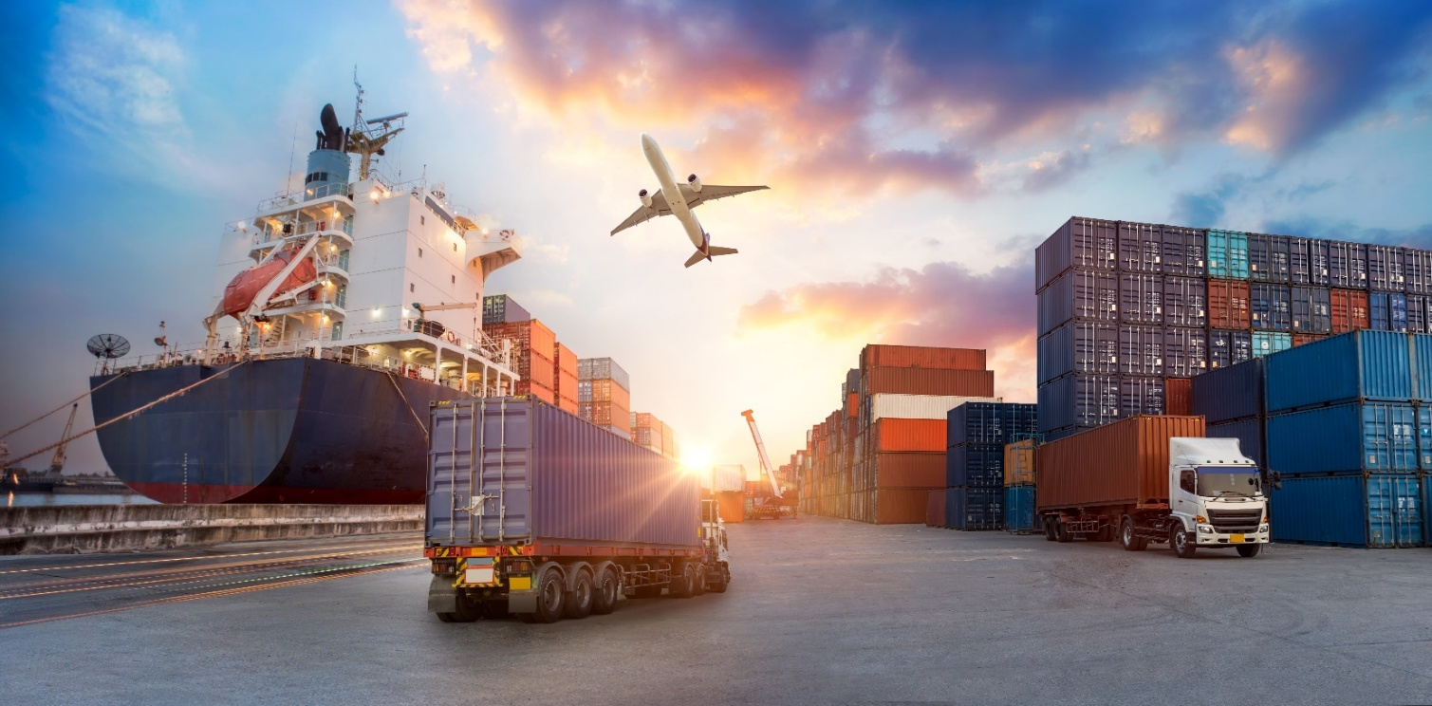
Cover image: Sourced from Adobe Stock photos. Credit: Travel mania.
All other images sourced from Department of Infrastructure, Transport, Regional Development, Communications, Sport and the Arts
© Commonwealth of Australia 2026
ISBN 978-1-923111-04-2

Ownership of intellectual property rights in this publication
Unless otherwise noted, copyright (and any other intellectual property rights, if any) in this publication is owned by the Commonwealth of Australia (referred to below as the Commonwealth).

Disclaimer
The material contained in this publication is made available on the understanding that the Commonwealth is not providing professional advice, and that users exercise their own skill and care with respect to its use, and seek independent advice if necessary.
The Commonwealth makes no representations or warranties as to the contents or accuracy of the information contained in this publication. To the extent permitted by law, the Commonwealth disclaims liability to any person or organisation in respect of anything done, or omitted to be done, in reliance upon information contained in this publication.

Creative Commons licence


With the exception of (a) the Coat of Arms; (b) the Department of Infrastructure, Transport, Regional Development, Communications, Sport and the Arts photos and graphics; (c) content supplied by third parties; (d) content otherwise labelled; copyright in this publication is licensed under a Creative Commons BY Attribution 4.0 International Licence.

Use of the Coat of Arms
The Department of the Prime Minister and Cabinet (PM&C) sets the terms under which the Coat of Arms is used. Please refer to the Commonwealth Coat of Arms Information and Guidelines | PM&C.

Contact us
This publication is available in PDF and Word format. All other rights are reserved, including in relation to any departmental logos or trademarks which may exist. For enquiries regarding the licence and any use of this publication, please contact:
Email: FreightStrategy@infrastructure.gov.au
Website: National Freight and Supply Chain Strategy

Table of Contents
Acknowledgment of country 5
The 2026 fuel security disruption – an unprecedented challenge 6
Foreword 7
National Freight and Supply Chain Strategy 8
Strategy in the national context 10
Delivering the NSW Freight Policy Reform Program 10
Victoria Delivers 10
Queensland Freight Delivery Plan 11
Tasmania 11
Western Australia 12
Australian Capital Territory (ACT) 12
South Australia 13
Northern Territory 14
New technology case studies 15
Our progress 17
Context 17
Decarbonising the freight and supply chain sector 19
Improved efficiency, productivity and international competitiveness 21
Safe, secure and resilient supply chains 24
Looking ahead 30

List of Figures and Tables
Figure 1 Domestic freight by transport mode—total bulk and non–bulk 17
Figure 2 Domestic freight by transport mode—bulk 18
Figure 3 Domestic freight by transport mode—non-bulk 18
Figure 4 Freight transport full fuel cycle greenhouse gas (carbon dioxide equivalent) emissions, by transport mode 19
Figure 5 Emissions intensity by transport mode 2024-25 20
Figure 6 World Bank Logistics Performance Index 22
Figure 7 Australia's LPI score for each domain 22
Figure 8 Producer Price Indexes, June quarter 2015 to June quarter 2025. 23
Figure 9 Number of unplanned closures of the National Land Transport road network due to fire or flood 2023-24 and 2024-25 24
Figure 10 Count of fatalities and crashes involving trucks 25
Figure 11 Rate of fatalities and fatal crashes involving trucks (per billion vehicle kilometres travelled) 26
Figure 12 Number of train fatalities and serious injuries 27
Table 1 Collision and near hit incidents involving freight trains at level crossings 27
Figure 13 Fatality rate of employees in the Transport, Postal and Warehousing industry 28
Figure 14 Serious claims worker compensation injury incidence rate in the Transport, Postal and Warehousing industry 29
Table 2 Summary of National Action Plan 30

Acknowledgment of country
We acknowledge First Nations people as the Traditional Owners and Custodians of Australia and the Torres Strait Islands. Their deep-rooted connection to the land and waterways is integral to the nation’s cultural heritage and the sustainable management of resources. Aboriginal and Torres Strait Islander peoples, as part of the world’s oldest living culture, have successfully managed the lands and resources across Australia for over 65,000 years. This enduring relationship with the land provides valuable insights for developing resilient and sustainable supply chains.
The ancient trade routes, which followed song lines and ceremonial paths across Aboriginal and Torres Strait Islander lands, highlight the sophisticated systems of trade and communication established by First Nations people over tens of thousands of years. We honour the First Nations peoples of Australia and pay our respects to Elders past and present, acknowledging their contributions to the land and its stewardship, which continue to inspire sustainable practices within the national freight and supply chain framework.


The 2026 fuel security disruption – an unprecedented challenge
In the first half of 2026, a conflict in the Middle East resulted in major disruptions to global supply chains, and some fuel disruptions in Australia. At the time of publishing this annual report, Australian governments’ priority is to alleviate the pressures caused by the fuel security crisis. Governments are working closely with industries and our international partners to diversify supplies, quickly address local shortages, and bring prices down. Governments recognise how critical this is for the freight and logistics sector, and how tough conditions are in the current climate for everyone working to keep goods moving across the country.
This Annual Report – prepared prior to the crisis – remains a useful accountability mechanism under the National Freight and Supply Chain Strategy. The data and trends contained in this report remain essential for long term planning. Understanding our freight networks’ performance on decarbonisation, efficiency and safety will be fundamental to building a more resilient freight network and supply chain for the future. Governments thank all those in the freight and logistics sector for their efforts during this challenging period and remain committed to supporting the sector through both immediate response and longer-term strategy and investment.

Foreword
Freight transportation is the backbone of Australia’s way of life.
We are pleased to present the National Freight and Supply Chain Strategy Annual Report 2024-25. The first since the Strategy’s refresh this year.
The 2025-2029 Strategy was released outside the reporting period for this 2024-25 report, however officials are already progressing work on a number of actions. This report is built around the first year of reporting against the key performance measures, setting the baseline for future reports.
The refreshed Strategy was developed through close collaboration between jurisdictions, industry partners, and stakeholders. This cooperative approach ensures that the Strategy remains practical, forward-looking, and aligned with national priorities. By working together, we have strengthened the foundations for a resilient, efficient, and sustainable freight network that supports economic growth and community wellbeing.
Freight and supply chains play a critical role in connecting businesses, regions, and people. The refreshed Strategy provides a clear roadmap for coordinated action, enabling governments and industry to respond to emerging trends, harness innovation, and maintain Australia’s competitiveness in a rapidly changing global environment.
We invite you to explore this report and join us in continuing to deliver on the shared vision for a world-class freight system.
Infrastructure and Transport Senior Officials' Committee

National Freight and Supply Chain Strategy
Australia’s economy is underpinned by efficient transportation of freight across vast distances and international borders. Our domestic supply chains are a critical enabler of Australia’s international trade and provide the link between our trade gateways (ports and airports) and the broader economy.
The original National Freight and Supply Chain Strategy (the Strategy) was released in 2019 and brought together governments and industry to improve the efficiency, effectiveness and reliability of Australian supply chains. In 2023-24, the first 5-year review acknowledged the strengths of the Strategy but identified some areas for improvement. National, state and local governments worked together with industry to deliver a new version of the Strategy, with a renewed focus on collaboration in areas of national interest.
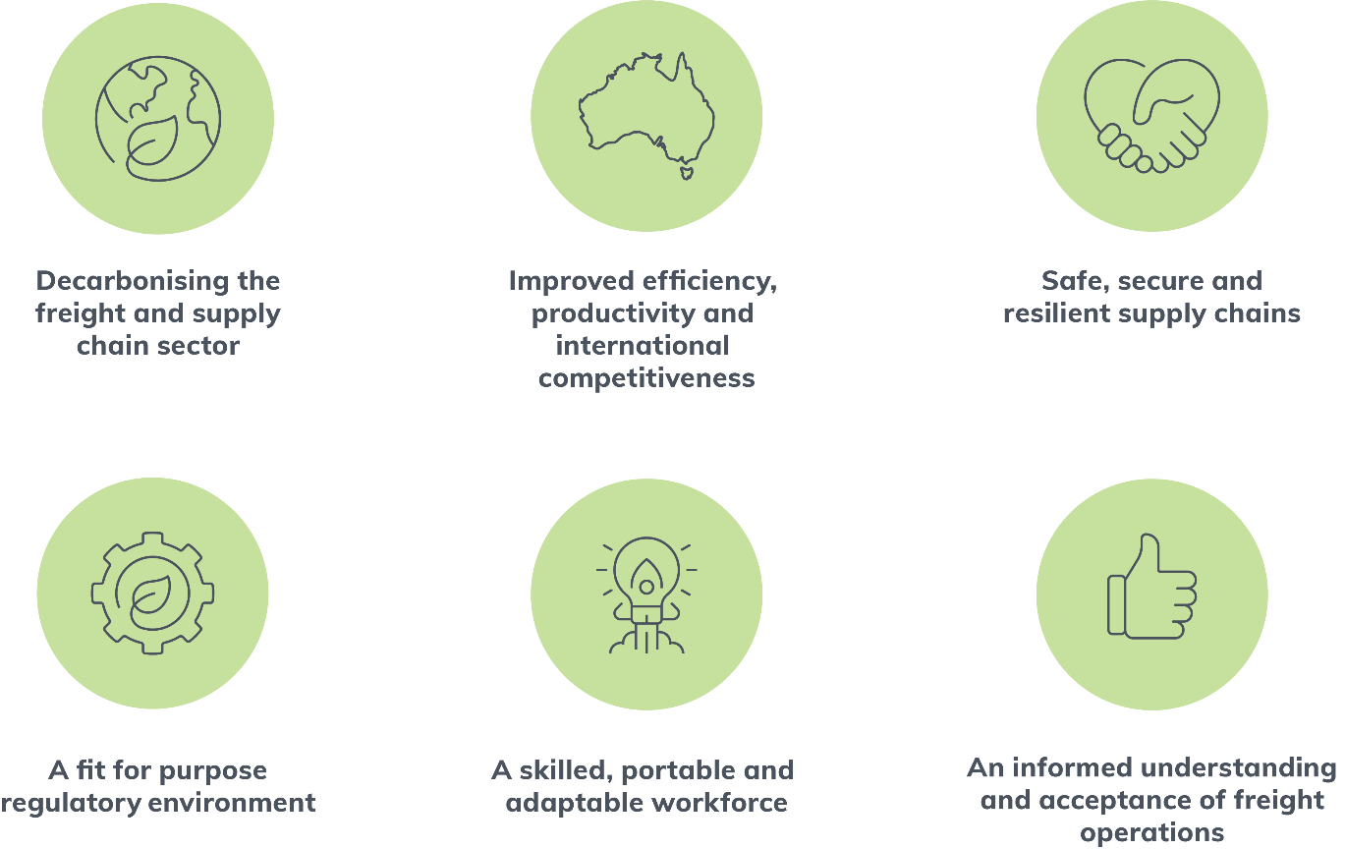
The Strategy was refreshed and launched in August 2025 along with a new National Action Plan. It includes new and refined goals as well as new ways of working together. The 14 targeted actions align to the National Priority Action Areas identified through the refresh process (See Appendix A –National Action Plan Summary). All governments are working together to deliver these actions.
The actions are forward looking, focusing on the current and emerging key strategic issues facing industry. Their impact will be felt in the freight and supply chain system as a whole and are not unique to a single mode.
This is the fourth annual progress report and covers progress made in the 2024-25 financial year. Since the Strategy’s release, annual reports have been made in 2019-20, 2020-21 and 2021-22. No reports were produced in 2023 and 2024 due to the 5-year review and refresh of the Strategy being undertaken during this period.
The Strategy includes an initial set of key performance measures to provide a picture of the freight and supply chain sector, but further work will begin next year to expand and refine the list.
As the release of the refreshed Strategy in August 2025 is outside the reporting period, this annual report is built around the first year of reporting against the initial key performance measures. Several actions have commenced analysis, scoping or consultation with jurisdictions, however there has been insufficient time to complete any actions since the Strategy was released. As such, progress is not contained in this year’s annual report but will be in future years. Descriptions of the actions are contained at the end of this report in the ‘Looking Ahead’ section.
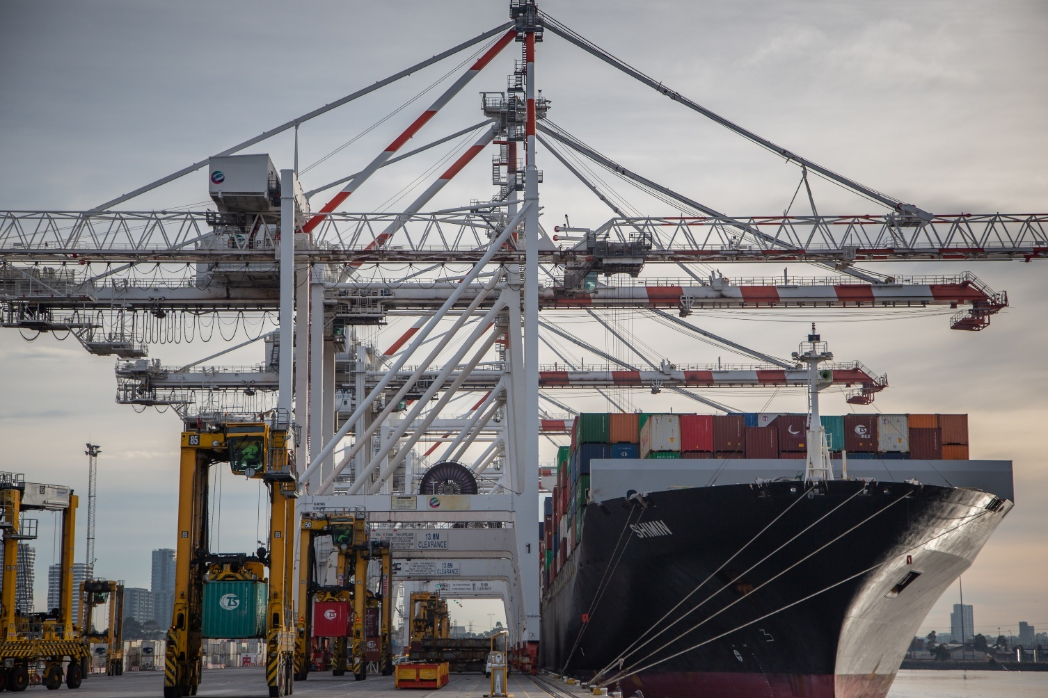

Strategy in the national context
The Strategy’s development and ongoing implementation is a collaborative endeavour across all levels of government. Each jurisdiction has aligned their policies and programs to the national focus set out in the Strategy. Each jurisdiction’s contribution is set out below.

Delivering the NSW Freight Policy Reform Program
The NSW Government has undertaken the NSW Freight Policy Reform which has delivered a comprehensive strategic reform agenda to optimise the freight system in NSW with an independent advisory panel comprising of Dr Kerry Schott AO, Mr Lucio Di Bartolomeo and Dr Hermione Parsons.
This reform program was a system-wide policy review of the freight system, including road, rail and ports. Industry wide issues and critical facilities that form part of the supply chain such as intermodals, workforce and industrial lands were considered, recognising they play a critical role in the movement of goods across an integrated freight system.
The NSW Government developed guiding policy principles in relation to:
- The role of the NSW Government, Australian Government and industry in making a step change in freight transport
- The major ports in NSW
- The road and rail network
- The supporting metropolitan and regional intermodal terminals and other enabling transport infrastructure
- The consideration of freight in the identification and use of industrial land
- Embedding freight considerations into transport planning, prioritisation and investment decisions.
The guiding principles have been used to provide a framework of policy positions to optimise safety, productivity and sustainability; define the role of the NSW Government, Australian Government and industry; and develop short, medium and long-term actions.
There is strong alignment between the National Freight and Supply Chain Strategy and the NSW Freight Policy Reform. The NSW Government has commenced implementation of the Freight Policy Reform Program to deliver improved freight outcomes for the people of NSW.


Victoria Delivers
The Victorian Freight Plan 2025-30: Victoria Delivers was released on 6 August 2025. It is the Victorian Government's plan to meet the challenge of higher freight volumes as the state’s population continues to grow and demand for freight continues to increase. The plan’s vision is to protect and strengthen Victoria's competitive advantage, and to enhance Victoria's liveability and economic prosperity.
Resilient, productive and sustainable freight connections are essential to the success of Victoria’s businesses and communities. The Victorian freight industry employs around 240,000 people and generates more growth and jobs from freight than any other state. Victoria’s freight task is expected to increase from around 440 million tonnes in 2020-21 to 908 million tonnes by 2050-51. That growth is being accelerated by an increased momentum for decarbonisation, and opportunities to boost supply chain efficiency, safety and connectivity through technological innovation and improved access to data.
Victoria Delivers builds on the success of the last Victorian Freight Plan, Delivering the Goods, released in 2018 and is the roadmap for our freight system. It outlines the high-level objectives, strategic priority areas and the actions that will be taken to deliver on the objectives over the next five years to support thriving freight and supply chains in Victoria.
As a long-term blueprint, it will be used to guide policy development; strengthen protection, planning and delivery practices; embed safety; support innovative technology and decarbonisation pathways; create certainty for investment; ensure fit for purpose infrastructure; improve data availability and research; and foster a skilled and diverse workforce. There is strong alignment between Victoria Delivers and the National Freight and Supply Chain Strategy. Victoria Delivers can be found at: https://www.vic.gov.au/freight-victoria.


Queensland Freight Delivery Plan
In 2025, the Queensland Government commenced the development of a new Queensland Freight Delivery Plan. The plan will prioritise freight system innovation and improvements, in response to population growth and to help drive regional economic growth and productivity. A key focus of the plan will be enhancing the state’s capability in regional and long-distance freight haulage, and the cost-effective movement of commodities and goods to and from our ports.
Feedback from industry, government and regional stakeholders is informing the development of the plan, which will be progressed for government consideration in mid-2026.
The new Queensland Freight Delivery Plan will align with the updated priorities of the National Freight and Supply Chain Strategy, including efforts to improve Australia’s freight system safety, productivity, resilience, decarbonisation and underlying evidence base through better application of data.
The Queensland Government continues to support the actions being delivered through the National Action Plan in collaboration with the Australian Government and jurisdictional representatives.


Tasmania
The National Freight and Supply Chain Strategy aligns closely with Tasmania’s expectations for efficient, reliable, productive, sustainable, and safe freight movements and supply chains in Tasmania.
Tasmania’s freight network remains strong. In 2024-25, 14.3 million tonnes of freight transited through Tasmania’s ports, and TasRail hauled just over 498 million net tonne kilometres of freight.
The Tasmanian Government is investing heavily in Tasmania’s freight network. The new Bridgewater Bridge was officially opened in June 2025, the Tasmanian Freight Rail Revitalisation Program continues to provide critical investment in Tasmania’s rail network, and development at Tasmania’s four strategic ports is ongoing.
Together with significant investments in road, rail and port infrastructure, the Tasmanian Government is investing in the safety and wellbeing of freight and supply chain workers including through the Heavy Vehicle Driver Rest Area Strategy, and through supporting industry workforce development and physical and mental health programs to attract and retain workers in the freight and logistics sectors.
In 2024, the Tasmanian Government released the Transport Emissions Reduction and Resilience Plan 2024-29 to support our target of net-zero emissions by 2030 and the National Freight and Supply Chain Strategy’s goal of decarbonising the freight and supply chain sector.
Tasmania’s freight system underpins business and economic growth in the state. Effective and efficient transport networks and supply chains are a key enabler of realising the outcomes of the Tasmanian Government’s investment across key industry sectors.


Western Australia
Western Australia is actively aligning its freight and supply chain strategies with the National Freight and Supply Chain Strategy (NFSCS) through focused investments and policy initiatives designed to improve efficiency, decarbonisation, safety, and resilience across the State’s freight network. The Western Australian Government is currently developing a Regional Freight Strategy, accompanied by targeted Regional Action Plans. The Strategy is intended to outline region-specific priorities to address freight challenges and opportunities, with a strong emphasis on network efficiency, safer freight movement, and building resilience in line with the NFSCS.
Significant upgrades to ports and regional road networks are underway, enhancing freight capacity, efficiency, and safety. Improvements to secondary roads and the construction of bypasses are helping divert heavy vehicles from regional towns, increasing safety and reducing congestion. First point of entry planning and approvals, and capacity enhancements at regional ports are supporting trade resilience and efficiency.
Through the Agricultural Supply Chain Improvements program, investments are boosting rail capacity, allowing for heavier trains and increased throughput, with five out of 11 rail siding upgrades completed and the remainder anticipated by 2026. The WA Government is also pursuing the strategic objective of regaining control of the freight rail network to further encourage rail freight uptake and bolster regional road safety.
Efforts are ongoing to develop a transition plan for battery-electric heavy vehicles and supporting charging infrastructure, alongside investigations into the capability of WA’s ports and roads to transport renewable energy equipment.
Together, these initiatives demonstrate WA’s commitment to continuous improvement, industry collaboration, and innovative solutions to meet emerging freight sector challenges.


Australian Capital Territory (ACT)
The ACT Government supports the refreshed National Freight and Supply Chain Strategy and its agenda for a collaborative approach to deliver actions by governments and industry, including on the transition to net zero. The bulk of freight in the ACT is handled by the private sector, but the ACT Government ensures the supporting infrastructure, such as roads and land availability, is as reliable, efficient and as strategically located as possible. Nearly all freight (by volume) into and out of the ACT is road based, with most of the freight task originating from New South Wales, with Victoria second. ACT is focusing on enhancing regional connectivity through rail between Canberra and Sydney, road freight routes for trade connections to inland and coast regions, and air routes that link Canberra locally, nationally and to the world.
ACT Transport Strategy 2020 and the ACT Freight Strategy 2016 set out a vision to deliver an efficient, safe and sustainable freight network and services for a growing ACT and regional economy while protecting urban amenity and freight access and reducing the emission intensity of the freight transport industry. The ACT Government has committed to develop a refreshed Planning Strategy which combines the Transport Strategy into one new integrated strategy. The ACT Government is also developing a new ACT Climate Change Strategy for 2026–35. The strategy will set a clear direction for reducing emissions, preparing for climate impacts, and supporting a fair and inclusive transition to a net zero, climate-resilient city by 2045. Work to develop these new strategies will consider how the ACT Government can continue to support an efficient, sustainable and safe freight network and collaborate across government and industry to support zero emissions freight options. The ACT Government is also actively engaged with the Australian Government’s Productivity Commission in reviewing the local impacts of proposed heavy vehicle productivity reform on the ACT.


South Australia
In June 2024, the South Australian Government released the Freight and Supply Chain Strategy (the Strategy). The Strategy has been developed in strong collaboration with an 18-person committee that represented all facets of the sector – Road, Rail, Sea, Air, Regulators, peak industry bodies and Unions. The Strategy has been co-designed with industry and key stakeholders so that it reflects and addresses the issues and opportunities experienced on the ground.
The Strategy:
- provides a vision for a commercial freight and supply chain network that is safe, productive, and sustainable for the State
- sets out the outcomes that are key to the future success of the sector in supporting the South Australian economy
- provides a suite of responses and strategic actions that will guide policy, planning and investment over the coming decades
A total of 22 strategic actions will in turn drive future initiatives and investment, and include:
- improving infrastructure and access to increase supply chain productivity
- planning for supply chain infrastructure to minimise the risk of disruption
- working with the industry to understand current and emerging technology and innovation developments and supporting their use where suitable
- providing direction and strategic support to promote sector-wide decarbonisation that aligns with net zero commitments
Delivery of the strategy’s vision will be guided by eight responses, including:
- a safe and connected network
- resilience and redundancy
- technology integration
- regulation and policy harmony
The Department is currently preparing a draft implementation plan. The plan will outline a specific program of initiatives and projects that will be delivered over the short, medium and long term.
South Australia’s Strategy is published on the Department for Infrastructure and Transport’s website.


Northern Territory
The Northern Territory plays a unique and strategic role in Australia’s freight and supply chain system. While the Territory accounts for a relatively small share of total freight volumes, it is critical to connecting Australia to international markets through the Port of Darwin – Australia’s only capital city port facing Asia. The north–south corridor linking Darwin and Adelaide by both rail and road is a nationally significant supply chain, enabling the movement of bulk commodities, critical minerals and general freight between southern markets and international gateways. As Australia’s northern gateway, the NT’s key freight corridors support national trade and defence priorities while also underpinning essential access for remote communities across the Territory.
The Territory’s freight system faces challenges that are distinct from other jurisdictions. Vast distances, sparse population, reliance on a limited number of key corridors, and vulnerability to natural disasters such as cyclones, flooding and bushfires make resilience planning essential. Ensuring secure, reliable access to remote and regional communities is a priority, particularly for the supply of food, fuel and essential services. These issues highlight the importance of actions under the National Strategy related to resilience planning, skills development and investment in nationally significant corridors.
The NT Government, in collaboration with the National Intermodal Corporation, is working to expand rail sidings and spurs and improve rail efficiency and multimodal freight capacity. These initiatives aim to reduce the reliance on long-distance road transport, lowering heavy vehicle traffic across the Territory and contributing to a more efficient and sustainable freight network.
The National Freight and Supply Chain Strategy (NFSCS) aligns closely with the Northern Territory’s freight priorities, particularly the focus on strengthening nationally significant north–south and east–west corridors, enhancing the resilience of supply routes to remote and regional communities, and supporting long-term trade growth through the Port of Darwin.
The Territory’s freight planning emphasises resilience to natural disasters, supply reliability for isolated communities, and investment in critical infrastructure that supports national trade objectives, particularly the movement of critical minerals and energy exports. The NFSCS provides a valuable framework for aligning the Territory’s efforts with national priorities, ensuring that small but strategically significant jurisdictions are fully integrated into supply chain planning.
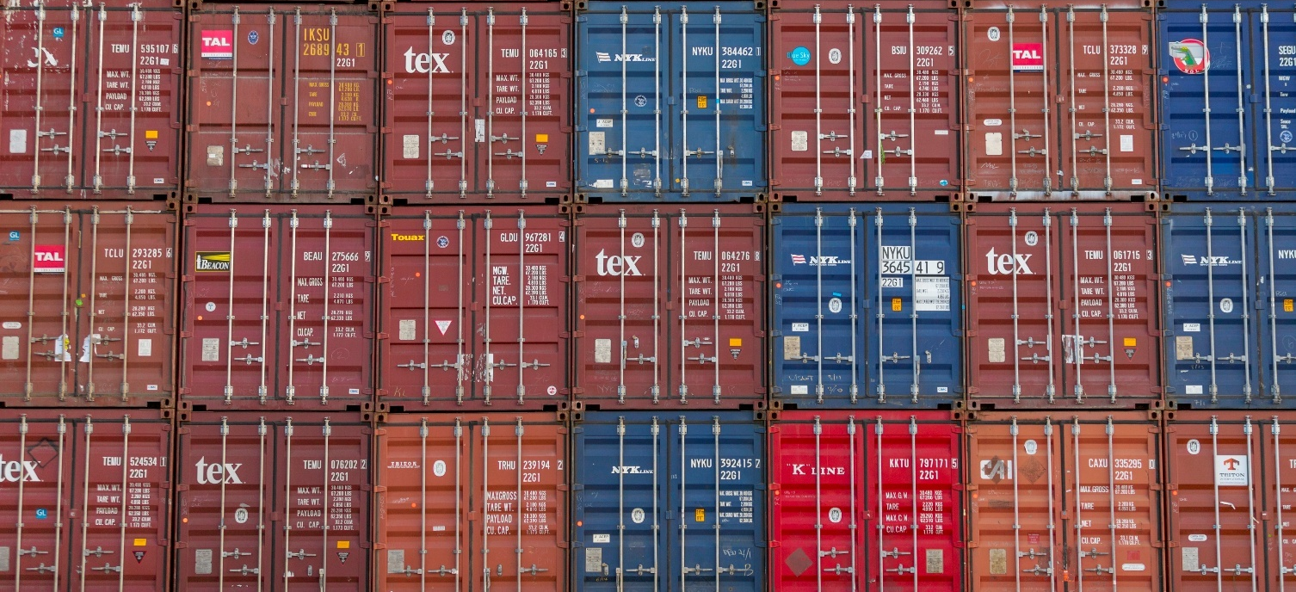The NT is anticipating the development of an updated Territory freight master plan in 2026 and it is expected that the plan will align closely with the new National Freight and Supply Chain Strategy and reflect the Territory’s evolving infrastructure and industry needs.

New technology case studies
Action 1.4 of the National Action Plan promotes the uptake of technology to improve safety, productivity and reduced carbon emissions. This is an ongoing project that will be conducted over the life of the Strategy. Each annual report will contain case studies that highlight some technologies and trials that have the potential for national impact.
Main Roads WA Cooperative Intelligent Transport Systems (C-ITS) Trial
Main Roads Western Australia partnered with the Queensland Department of Transport and Main Roads to deliver a Cooperative Intelligent Transport Systems (C-ITS) Pre-Deployment along the Mitchell Freeway southbound corridor from Hester Avenue to Vincent Street.
C-ITS technologies enable secure, real-time communication between vehicles and roadside infrastructure, providing drivers with location-specific warnings and safety information. Conducted between February and August 2024, this pre-deployment tested in-vehicle awareness and warning messages to establish the technical, operational, and communications foundations required for broader rollout across the State.
Vehicles equipped with C-ITS technology received advance warnings of roadworks, temporary speed limit changes, and real-time alerts about upcoming hazards. Results demonstrated how connected vehicle technologies can enhance driver awareness, improve compliance at roadworks, and reduce speed variability, key contributors to safer, more predictable journeys.
Insights from this initiative directly shaped the Main Roads C-ITS Roadmap, which provides a structured pathway for deploying connected vehicle infrastructure across Western Australia’s metropolitan, regional, and freight corridors. From 2025/26 onwards, Main Roads will commence phased deployments targeting high-risk intersections, work zones, and freight routes to improve safety, reduce delays, and increase network productivity.
This pre-deployment represents a critical step toward a nationally harmonised C-ITS ecosystem, positioning Western Australia as a leader in future mobility and supporting safer, more reliable, and more efficient freight movement across the State.
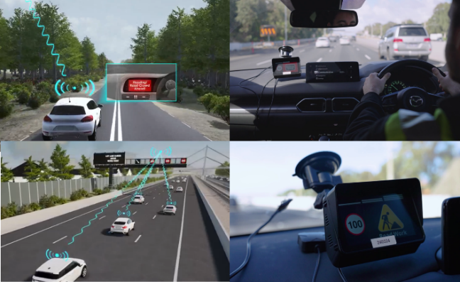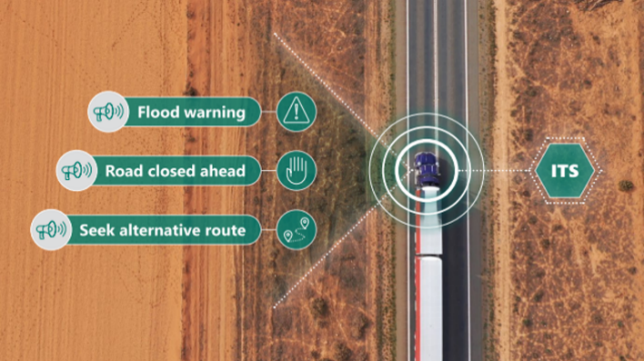

Drones for Roads
In an Australian first, Transport for NSW will be able to fly drones alongside and across highways for remotely piloted scheduled flights, without spotters, enabling them to rapidly respond to incidents near Greater Sydney traffic hotspots. The first drone-in-a-box units will be installed along key freight routes in Greater Sydney at the M1 near Mooney Mooney and the Hume Highway at Narellan, as part of the Drones for Roads Program.
Each flight is fully supervised by an accredited Transport Management Centre (TMC) pilot, with drones equipped with fail-safe systems, approved flight zones, and onboard diagnostics. From the TMC nerve centre, pilots can deploy and control drones located more than 50km away, dramatically reducing the time it takes to get eyes on an incident.
The TMC has reported a significant reduction in disruption recovery times when a drone has been deployed to help get people and freight moving faster after a traffic disruption on NSW roads. In the last year drones have responded to around 150 incidents, more than 120 where there have been full lane closures.
Live drone streams provide critical real-time situational awareness, enabling operators to assess incident severity, lane closures, queue lengths, and traffic conditions. This information is pushed to drivers via variable message signs and apps like Live Traffic, helping heavy vehicle drivers and freight operators plan routes and avoid delays.
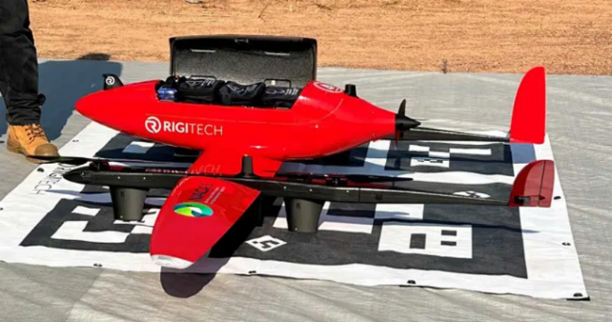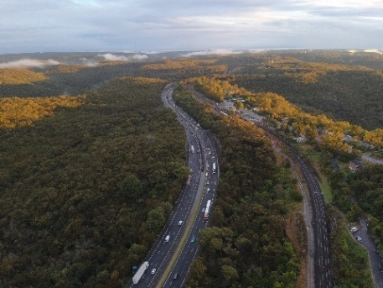
Remote Delivery Innovation
The Northern Territory has been trialling innovative technologies to improve the reliability and efficiency of freight services to remote and regional communities. In 2024–25, a pilot program was initiated to explore the use of drone and autonomous vehicle technology for last-mile delivery of medical supplies to communities cut off during seasonal flooding.
Led by Charles Darwin University’s North Australia Centre for Autonomous Systems, the pilot has investigated the feasibility of using autonomous drones to deliver small, high-value cargo into remote areas. A proof-of-concept trial between Jabiru and Gunbalanya aimed to establish a “last-mile airbridge” for medical deliveries, undertaken in collaboration with NT Health, iMOVE Australia, and local community health partners.
The technologies are not intended to replace heavy freight movements but to complement them by ensuring continuity of supply for time-sensitive goods when road and air access are restricted. Outcomes from the trial can inform broader national adoption of emerging freight technologies, particularly in the areas of supply chain resilience, decarbonisation, and service delivery to remote communities.

Our progress
As part of the Strategy refresh, key performance measures that align with Strategy goals were identified. These measures are intended to provide a holistic picture of the health of the freight and supply chain sector, and in future will sit alongside progress reporting on actions. As there has only been a short time since the launch of the refreshed Strategy, the actions will not be reported against in this report. Development of additional measures will be undertaken throughout 2025-26 and included in the 2026 report.

Context
Understanding changes in the freight task is important context for understanding changes in other freight-related measures. Absolute measures, such as carbon emissions or truck fatalities, can increase because there is more traffic on the roads, even if the accident rate or emissions intensity falls. Figure 1 shows Australia’s domestic freight task by mode.
The total freight task grew steadily peaking in 2018-19 but then declined during the pandemic, driven by falls in bulk freight across all modes particularly in heavy haul coal on rail. Growth returned within two years and the total freight task exceeded the pre-pandemic levels in 2023-24. Even with the pandemic falls, the total freight task has grown by 11% since 2014-15, driven by high growth in road (25%) and rail (11%) transport.
Figure 1 Domestic freight by transport mode—total bulk and non–bulk
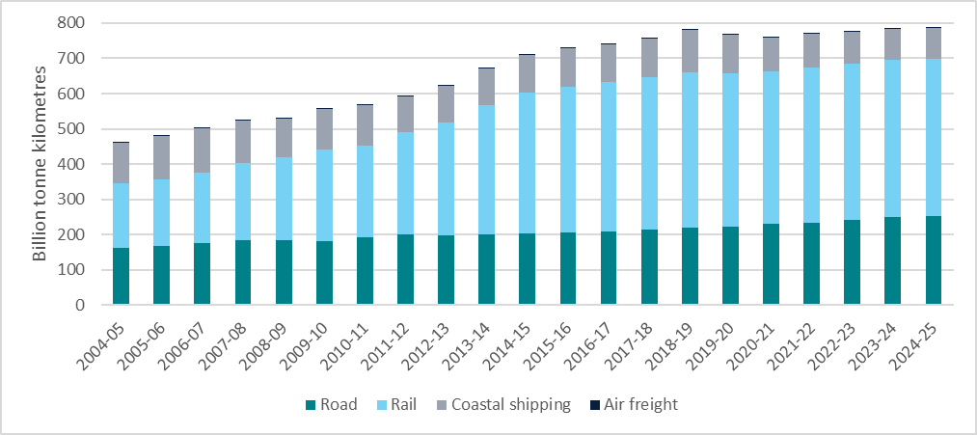
Source: BITRE (Bureau of Infrastructure and Transport Research Economics) 2025, Australian Infrastructure and Transport Statistics Yearbook 2025.
Around three-quarters of the domestic freight task is bulk, the majority of which is transported by rail (Figure 2). Heavy haul of iron ore from the Pilbara and coal from Central Queensland and the Hunter makes up 91% of the total rail freight task, and nearly half of all domestic freight by volume. Bulk rail is estimated to have declined by 0.5% in 2024-25. This decline is expected to continue as production of the largest bulk commodities reduce output. Bulk coastal shipping has also declined, driven by closures of production facilities across a number of industries.
Non-bulk freight is largely transported by road (Figure 3). Non-bulk freight has grown since 2014-15, driven by increases in road freight.
Figure 2 Domestic freight by transport mode—bulk
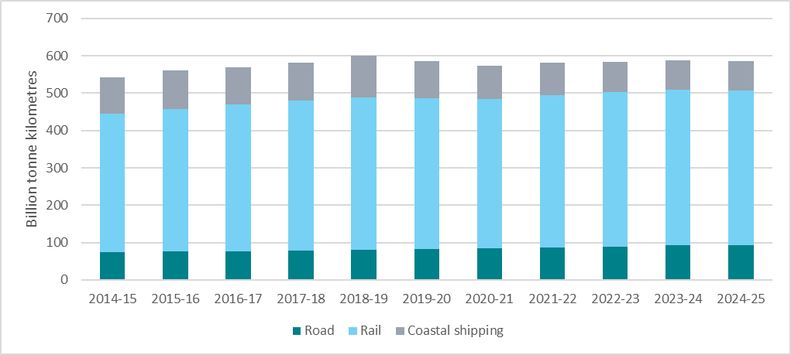
Source: BITRE, 2025, Australian Infrastructure and Transport Statistics Yearbook 2025.
Figure 3 Domestic freight by transport mode—non-bulk
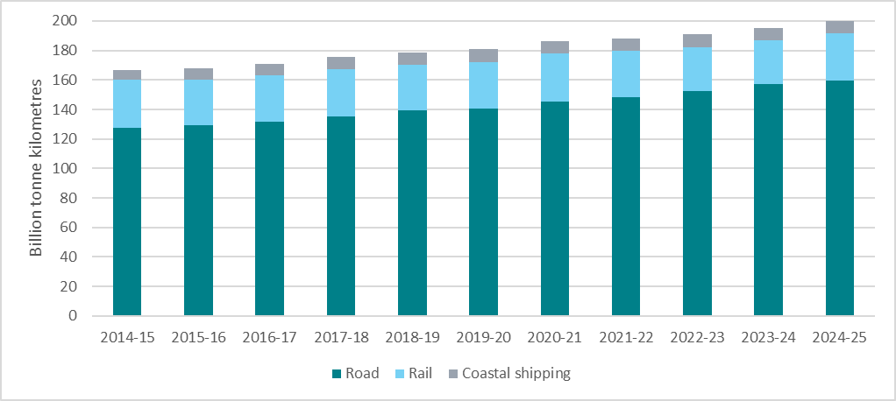
Source: BITRE, 2025, Australian Infrastructure and Transport Statistics Yearbook 2025.

Decarbonising the freight and supply chain sector

Goal
The freight and logistics sector is informed and actively involved with governments in developing the pathway to achieving net zero emissions for freight.
Measure: Emissions per tonne km per mode (including overall total, bulk and non-bulk).
Full fuel cycle greenhouse gas (carbon dioxide equivalent) emissions have been used for this measure which includes indirect emissions from energy generation and the transportation of fuels. As a result, this estimate is higher than freight’s contribution to the whole-of-economy figure, where emissions from energy generation and fuel transportation are allocated to the energy industry rather than freight. Freight transport emissions by mode are shown in Figure 4.
Figure 4 Freight transport full fuel cycle greenhouse gas (carbon dioxide equivalent) emissions, by transport mode
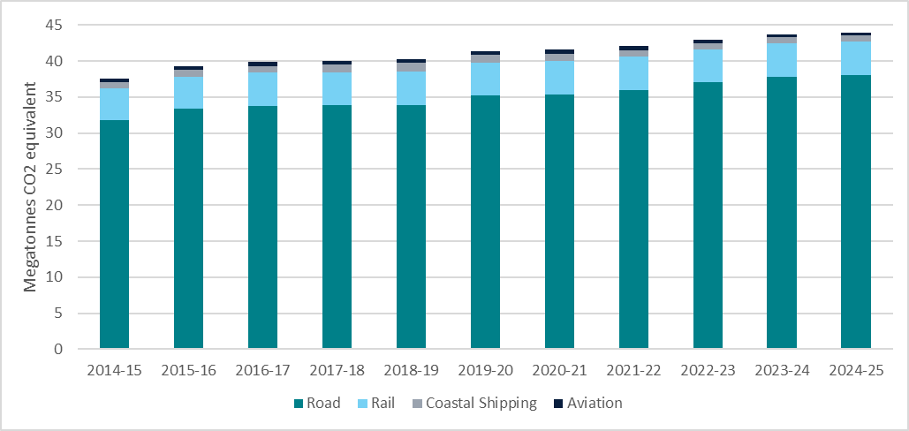
Source: BITRE, 2025, Australian Infrastructure and Transport Statistics Yearbook 2025, BITRE website.
Notes: Figures 4, 5 and 6 refer to full fuel cycle emission estimates for the civil domestic freight transport sector (Scope 1, 2 and 3 emissions from energy supply), in contrast to transport sector values in the Australian National Greenhouse Accounts for energy end-use (Scope 1 emissions) by domestic transport. Domestic maritime excludes small pleasure craft.
Total emissions have grown by 17% since 2014-15. While the growth is broadly in line with the current increasing freight task, the rate of growth is less than the previous two decades as emissions intensity falls. The increase in emissions is largely driven by growth in the road sector as they have greater mode share and higher emissions rate. Aviation has the lowest total emissions due to the small amount of freight carried by air, but the sector has the highest emissions rate in grams CO₂–e per tonne kilometre.

Emissions intensity tells us whether emissions are falling for each unit of freight transported, as total emissions may continue rise as the freight task increases, even though the freight industry is becoming more carbon efficient. Bulk rail and coastal shipping have the lowest emissions intensity, followed by non-bulk rail while road has the highest emissions intensity. The emissions intensity has decreased over the last decade for coastal shipping non-bulk (12.8%), road (4.2%) and bulk rail (3.0%). There is no change in the other modes.
Figure 5 Emissions intensity by transport mode 2024-25
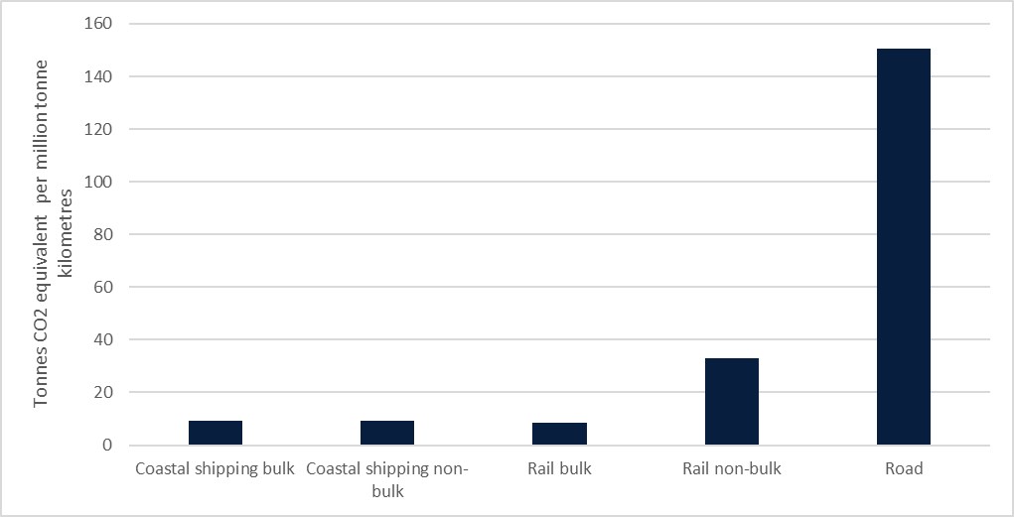
Source: Analysis of BITRE, 2025, Australian Infrastructure and Transport Statistics Yearbook 2025, BITRE website.

Improved efficiency, productivity and international competitiveness

Goal
Freight precincts, rail, maritime and air connections are planned, efficient and reliable. Industry is provided with greater certainty for future freight infrastructure investments. Industry uses new technologies to improve productivity across the freight task and strengthen Australia’s international trade.
Measure: Benchmark Australia’s international freight performance using the World Bank’s Logistics Performance Indicator (LPI).
Figure 6 shows Australia's results on the World Bank's Logistics Performance Index (LPI) compared to similar countries and to the 2023 leading country, Singapore. The LPI is a benchmarking tool intended to help countries measure and improve their logistics performance, such as the quality of logistics services, trade- and transport-related infrastructure, and border controls. As a global survey, it allows us to compare Australia’s international competitiveness against similar countries.
The overall index is an aggregation of six measures (see Figure 7) obtained from a worldwide survey of international logistics operators. The measures are calculated by asking operators to rate on a 5 point scale how they feel countries perform on each aspect. Each operator is asked to rate their own country and a selection of others.
- The efficiency of Customs and border management clearance.
- The quality of trade- and transport-related Infrastructure.
- The ease of arranging competitively priced International shipments.
- The Competence and quality of logistics services.
- The ability to Track and trace consignments.
- The frequency with which shipments reach consignees within the scheduled or expected delivery time (Timeliness).
In 2023, Australia’s LPI score (3.7) lagged behind Canada (4.0), Singapore (4.3) and the United States of America (USA) (3.8) and equalled the United Kingdom (3.7). Singapore was the highest ranked country in 2023, while Australia and the United Kingdom tied on 19th out of 139 countries.
Australia performed best on the Infrastructure and Tracking and tracing scores, both 4.1. The Infrastructure score was still lower than Canada (4.3) and Singapore (4.6). The Tracking and tracing score trailed Singapore (4.4), the United States (4.2) and equalled Canada (4.1). Australia’s Timeliness and International shipments scores were the lowest of all the comparator countries, including New Zealand.
Figure 6 World Bank Logistics Performance Index

Source: World Bank 2023, Logistics Performance Index (LPI), World Bank website.
Australia's LPI score has declined gradually since 2016. This is largely driven by falls in the ease of arranging competitively priced International shipments since 2016, and the Timeliness score (Figure 7). Australia’s geographic isolation leads to high international shipping costs. At the time of the latest survey, Australia’s maritime transport costs were at historical highs (see Figure 8). Australia also has higher ship turnaround times than other countries, due to fewer cranes in each port, leading to higher costs for operators. The timeliness of international shipments is subject to increased global disruptions and delays, decreasing maritime schedule reliability. Domestically, shipments are subject to road and rail disruptions due to extreme weather. The latest survey was conducted late in 2022, when the impacts of significant flooding along the east coast were still being felt.
Figure 7 Australia's LPI score for each domain
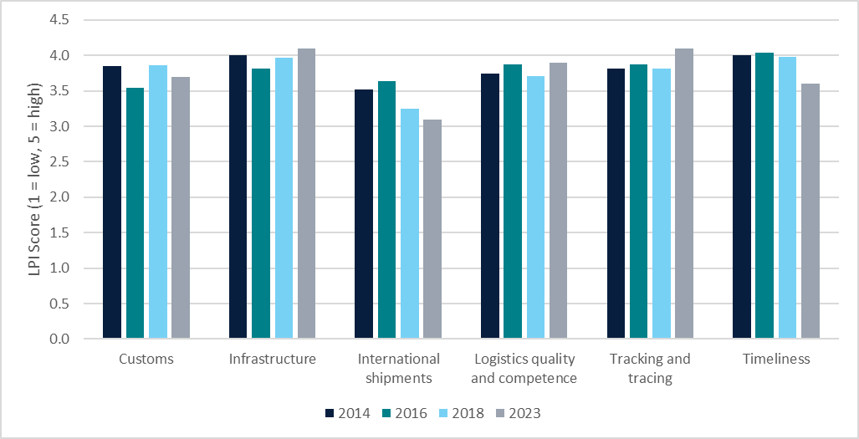
Source: World Bank 2023, Logistics Performance Index (LPI), World Bank website.
Measure: Price indicators of road, rail and maritime freight provided by ABS.
Figure 8 shows the ABS’ Producer Price Indexes (PPIs) for road, rail, and maritime freight. The PPIs are a measure of the price to produce items, and in the freight case, the price to transport goods. The index is relatively stable prior to 2021 but has since risen. The spike in maritime freight costs between June 2020 and June 2022 was driven by port congestion caused by COVID-19 delays, particularly across Asia and Europe. Unlike road and rail, the prices for maritime freight used here includes Australian use of international shipping, and therefore is influenced by international drivers. Increases in road and rail freight rates are largely driven by fuel price and wage increases, although flooding in late 2022 also had an impact on particular routes.
Figure 8 Producer Price Indexes, June quarter 2015 to June quarter 2025.
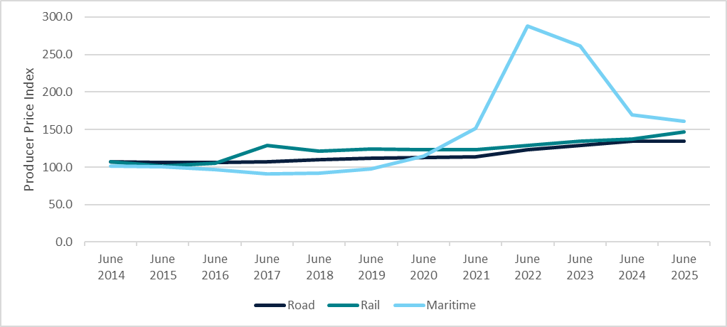
Source: ABS (Australian Bureau of Statistics), 2025, Producer Price Indexes, Australia, June 2025, ABS website.
Notes: Data represented is the quarterly result for the reference date. Index reference period 2011-12 = 100.0

Safe, secure and resilient supply chains

Goal
Australia’s freight networks and supply chains are safe, secure and resilient across all modes. Resilience is an essential consideration when future infrastructure investment is being planned.
Measure: Number of unplanned closures and number of days of unplanned closures on key routes.
Figure 9 shows the number of unplanned closures of roads on the National Land Transport network due to fire or flood. This measure is significantly influenced by the severity and location of the extreme weather season between years. These figures are calculated from publicly available data that is harmonised by the National Freight Data Hub. The outage is allocated according to the location of the road that is closed, with the Major Cities and Regional categories defined by the ABS’ Remoteness Classification. Many outages do not have an end time contained within the data set, so the length of time of the outage is not possible to calculate. It is also not possible to exclude disruptions where the road is not fully closed.
Figure 9 Number of unplanned closures of the National Land Transport road network due to fire or flood 2023-24 and 2024-25
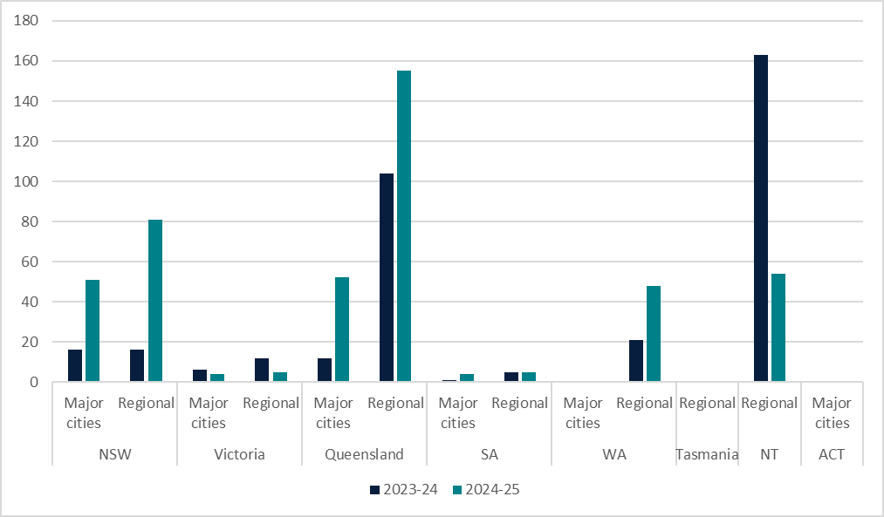
Source: BITRE 2025, analysis of Harmonised National Roadworks and Road Closures, National Freight Data Hub.
Notes: Major Cities are defined according to the ABS Remoteness Classification. Under this classification Darwin and Hobart is considered regional.
There were 12 major bushfires and 5 flooding events on mainland Australia in 2024-25. Queensland bore the brunt of the most severe events with flooding from 3 separate weather events, with flooding due to ex-Tropical Cyclone Alfred extending into New South Wales. Weather events in this period have disproportionally affected regional areas, which may have fewer alternative routes. Tasmania, ACT and Major Cities WA do not have an outage for this period.
Measure: Fatalities, injuries and near misses – Number of fatalities involving trucks.
Around 18 per cent of all road crash deaths involve a heavy vehicle. While heavy vehicles crash less often than other vehicles, these crashes are more likely to result in a death or serious injury. Figure 10 shows the number of fatalities and fatal crashes from all road crashes that involve a heavy vehicle. While the crashes all involve a truck, there is no information on the cause of the crash or whether the fatality was the driver of the truck or someone else. Each fatal crash can result in multiple fatalities at an average of 1.1 fatalities per crash. There were more fatal crashes in 2024-25 than the previous 10 years, but the number of fatalities were in the mid-range for the decade. The number of fatal crashes and fatalities during the pandemic years of 2019-20 and 2020-21 were lower than the trend, but in 2021-22 returned to pre-pandemic levels.
Figure 10 Count of fatalities and crashes involving trucks
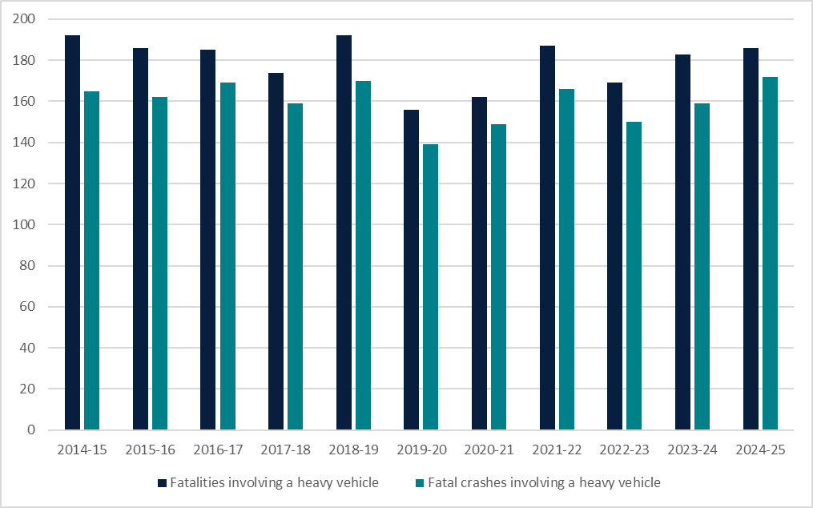
Source: BITRE, 2025, Heavy vehicle Road deaths, BITRE website.
The number of crashes and fatalities is influenced by the amount of traffic on Australia’s roads, which increases with the increasing population and freight task. Figure 11 shows the fatality and fatal crash rate since 2014-15, removing the effect of the freight task changes. Fatalities and fatal crashes have both declined since 2013-14 by 22% and 17% respectively. The decline during 2019-20 and 2020-21 is not due to the freight task, as this continued to increase during the pandemic, but likely reflects reduced general traffic as households limited their movement. While the fatal crash rate per billion kilometres is falling, heavy vehicles are still more likely to be involved in a fatality due to the long distances they travel.
Figure 11 Rate of fatalities and fatal crashes involving trucks (per billion vehicle kilometres travelled)
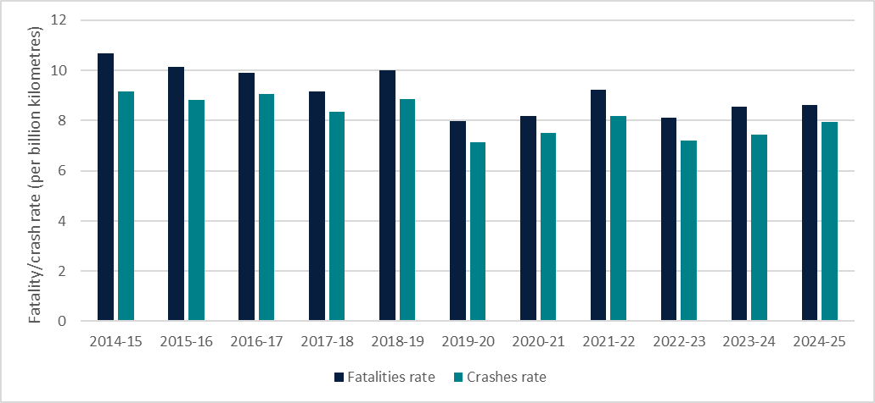
Source: BITRE, 2025, Heavy vehicle Road deaths, BITRE website; BITRE, 2025, Australian Infrastructure and Transport Statistics Yearbook 2025, BITRE website.
Measure: Fatalities, injuries and near misses – Number of fatalities, serious injuries, and near misses involving freight trains.
Figure 12 shows the number of fatalities and serious injuries on rail, freight and passenger. This data includes workers and members of the public, but not passengers, trespassers and those suspected of self-harm. The number of fatalities and injuries are small, particularly for fatalities, so a small number of incidents can result in large fluctuations in the numbers. This variability combined with the small numbers means that a rate is not meaningful.
Fatalities are more likely to be a member of the public, serious injuries since 2022 are more likely to be workers.
Figure 12 Number of train fatalities and serious injuries
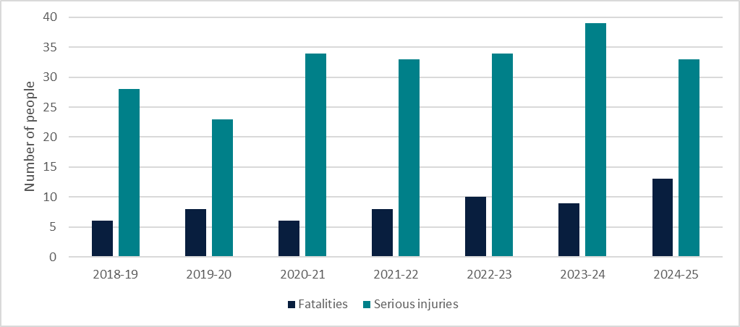
Source: ONRSR (Office of the National Rail Safety Regulator) 2025, National rail safety data, ONRSR website.
Note: Fatality and serious injury data is for all trains, freight or otherwise.
Collisions and near hits (formerly referred to as near misses) for freight trains at level crossings and running line are shown in Table 1. ONRSR has changed how this data is calculated, so consistent data is only available from 2022-23.
Table 1 Collision and near hit incidents involving freight trains at level crossings
Year | Level crossing collisions | Level crossing near hits | Running line collisions
2022-23 | 19 | 159 | 26
2023-24 | 22 | 283 | 33
2024-25 | 23 | 225 | 18
Source: ONRSR 2025, National rail safety data, ONRSR website.
Note: Data excludes suspected self-harm incidents.
Measure: Fatalities, injuries and near misses – Number of workplace fatalities in the Transport, Postal and Warehousing sector.
Figure 13 shows the fatality rate (deaths per 100,000 employees) for the Road Transport sub-industry, compared with the Transport, Postal and Warehousing industry as a whole, along with the all-industries combined average. Other sub-industries are not measured separately in the chart due to the small number of deaths in some years. The Transport, Postal and Warehousing industry has the second highest industry death rate, behind Agriculture. This rate is largely driven by the Road Transport sub-industry; however, the other sub-industries are also higher than the all-industry average. In 2023-24 more than a quarter (29%) of all work-related deaths were in the Transport, Postal and Warehousing industry, despite representing only 5% of the workforce.
Figure 13 Fatality rate of employees in the Transport, Postal and Warehousing industry
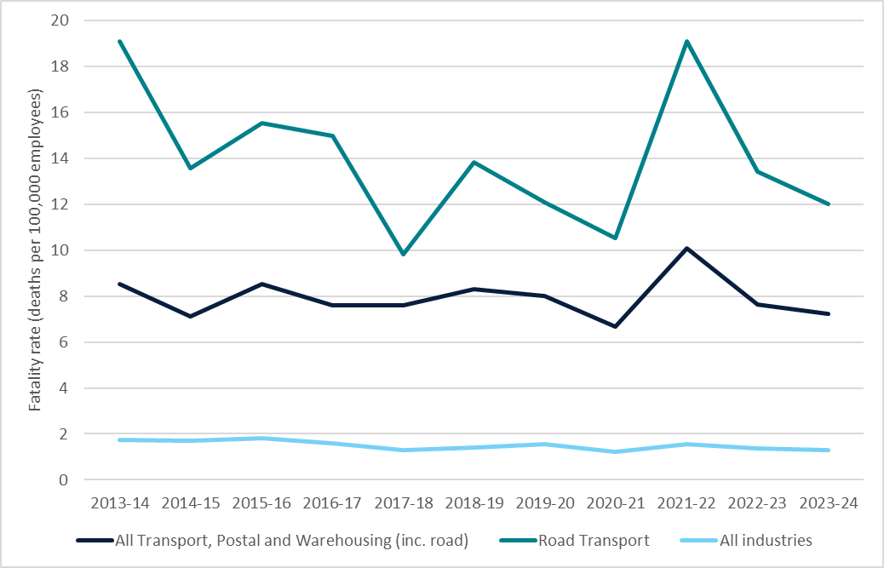
Source: Safe Work Australia 2025, Work related fatalities data, Safe Work website.
Truck drivers have the highest number of fatalities of any occupation. Vehicle collisions are the main reason for workplace fatalities, with nearly three in four truck driver fatalities due to a work-related vehicle incident. By contrast, vehicle incidents were the main mechanism for 42% of all workplace fatalities nationally.
Measure: Fatalities, injuries and near misses – Number of serious claims in the Transport, Postal and Warehousing sector.
The Transport, Postal and Warehousing industry also has a higher incidence rate of serious injury claims under worker’s compensation than the all-industry average (Figure 14). Higher incidence rates are seen in the Rail, Maritime and Transport Services sub-industries, as well as the Road sub-industry, although other Transport industries also have higher incidence rates than the all-industry average. For Truck drivers, the leading mechanisms of injuries for serious claims are body stressing and falls, trips and slips.
Figure 14 Serious claims worker compensation injury incidence rate in the Transport, Postal and Warehousing industry
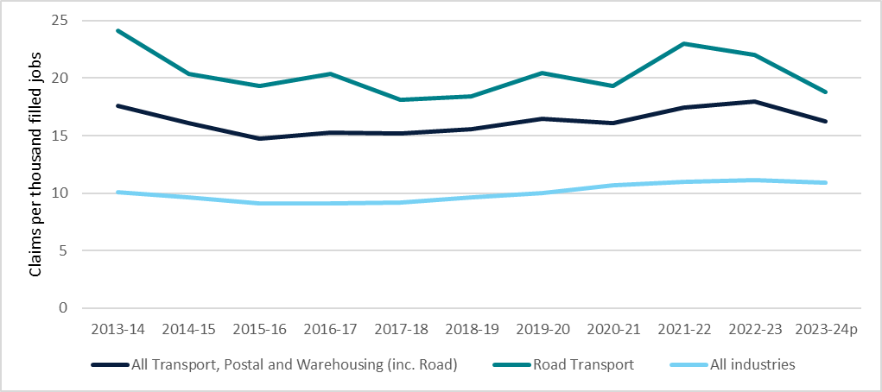
Source: Safe Work Australia 2025, Worker’s compensation data, Safe Work website.
Notes: Data for 2023-24 is preliminary; Incidence rate is the claims per thousand filled jobs covered under workers’ compensation schemes; Safe work changed their method for calculating rates so data from 2021-22 onwards represents a break in series. Interpret the trend with caution.

Looking ahead
The Strategy identifies 4 Priority Action Areas to advance its goals – Productivity, Resilience, Decarbonisation and Data – all underpinned by Safety. The National Action Plan sets out the activities that will be completed under these areas. Over 2025-26 governments will be completing or progressing a number of activities, with expected timeframes for delivery set out in Table 2. Several actions have commenced however there has been insufficient time to complete any actions since the Strategy was released. The next annual report will provide an update on progress to date on actions.
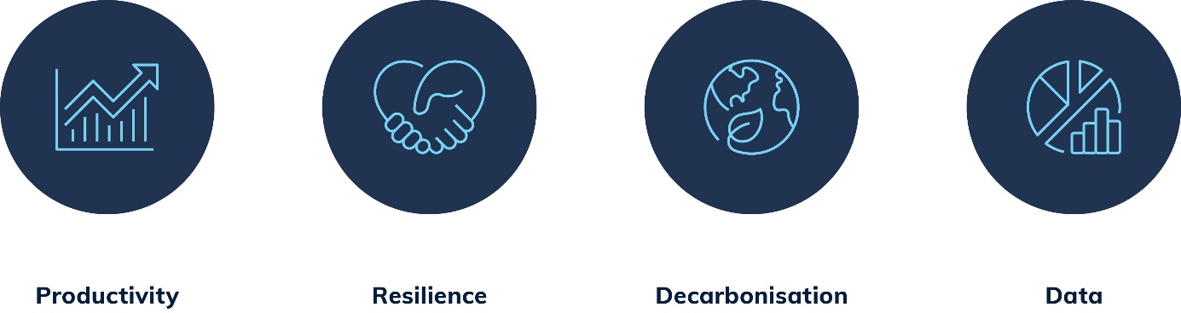
Table 2 Summary of National Action Plan
Action | Timeframe
Action 1.1: Define and model the current freight and supply chain network | 2025–26
Action 1.2: Model the ideal future freight network in 2040 | 2026–27
Action 1.3: Improve freight education and awareness in urban and industrial land use planning | 2025–26
Action 1.4: Promote uptake of technology to improve safety and productivity | Ongoing
Action 2.1: Develop a National Freight Resilience Plan | 2025
Action 2.2: Conduct periodic supply chain risk and resilience modelling | 2027–28
Action 2.3: Develop a Freight Infrastructure Investment Framework | 2025
Action 2.4: Conduct a current and future skills gap analysis for the freight and logistics sector | 2026
Action 3.1: Develop government and industry frameworks to collaborate on the transition to net zero | 2025–26
Action 3.2: Support development of a domestic low carbon liquid fuels industry | Ongoing
Action 3.3: Conduct safety research on batteries and zero emission power technologies for freight vehicles and locomotives | 2025–26
Action 4.1: Develop a data development plan to support the National Freight Data Hub | 2025–26
Action 4.2: Quantify the economic significance of the supply chain and freight logistics industry to Australia | 2025
Action 4.3: Develop additional key performance measures for future inclusion in the Strategy | 2026–27
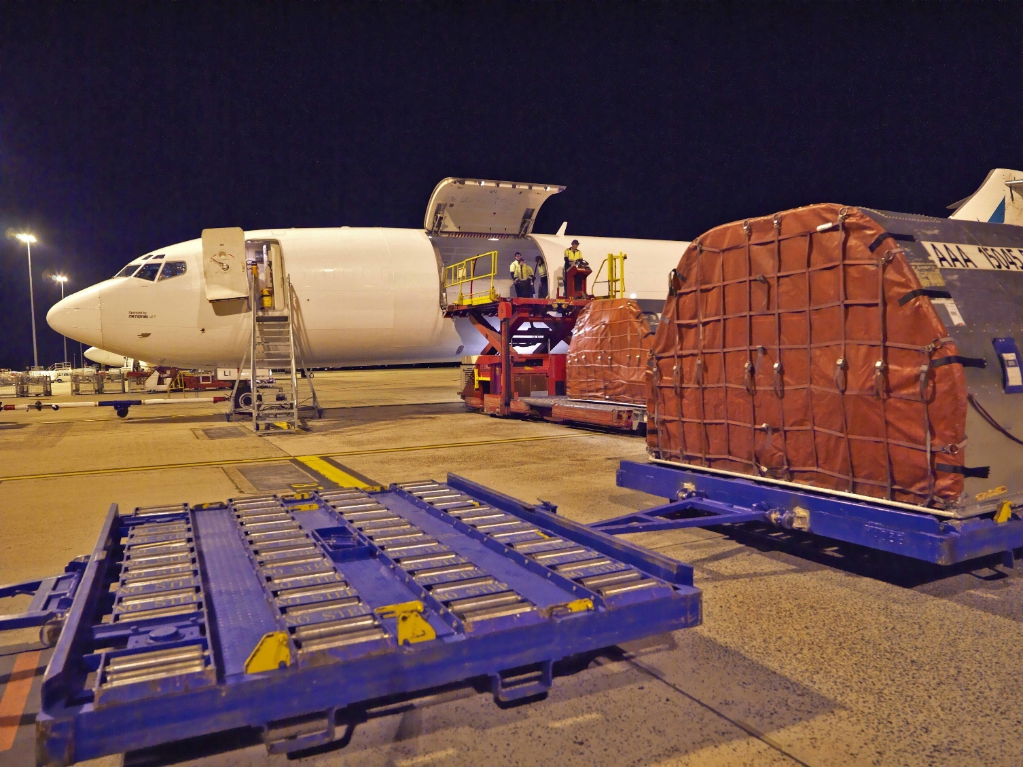

BITRE, 2022, Australian aggregate freight forecasts – 2022 update, BITRE website.
BITRE, 2023, Australian Sea Freight 2020-21, BITRE website.
BITRE 2023, Australian Infrastructure and Transport Statistics Yearbook 2023, BITRE website.
Calculated by dividing the amount of emissions from a sector by the activity by mode as shown in Figures 1 to 3.
Road emissions are not available broken down by bulk and non-bulk.
ABS 2022, Producer Price Indexes, Australia, December 2021
ABS 2023, Producer Price Indexes, Australia, December 2022.
For some jurisdictions, figures may include some disruptions that are not full closures. Figures are based on latitudes and longitudes provided by jurisdictions and applied to the NLTN with a 200m buffer, so in some cases may include incidents not directly on the NLTN.
AIDR (Australian institute for Disaster Resilience) 2025, Major Incidents Report 2025-25, AIDR website.
Calculated by dividing the number of truck fatalities/fatal crashes by the total vehicle kilometres travelled.
Data from the Office of the National Rail Safety Regulator doesn’t distinguish between freight and passenger rail.
Member of the public are those who have interacted with the train, either at level crossings or elsewhere on the track, without the intention of boarding as a passenger. Passengers have been excluded to reduce the number of non-freight train fatalities.
This industry classification includes passenger transport.
ABS, 2025, Labour Force, Australia, Detailed, July 2025, Table 04. Employed persons by Industry division of main job (ANZSIC) - Trend, Seasonally adjusted, and Original. Figures taken from Original series as at May quarter 2023.
Safe Work Australia 2025, WHS Profile: Truck drivers, Safe Work website.
This industry classification includes passenger transport.
A serious injury is one that resulted in a week or more off work.
The Transport sub-industries, except for Road Transport, have fewer incidences or employment, and so small changes in the numbers of incidences can result in large changes in the incidence rate. As such, they are not shown here separately.
This includes the Air and Space Transport, Other Transport, Postal and Courier Pick-up and Delivery Services, and Warehousing and Storage Services industries.
Safe Work Australia 2025, WHS Profile: Truck drivers, Safe Work website.

